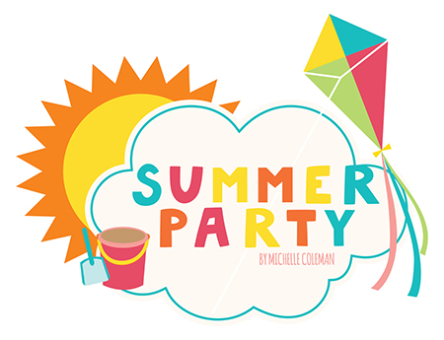 | The summer holidays are nearly here! On Thursday, June 27 we will be celebrating the end of the year as a whole Grade (2 teachers and 27 children). Please sign up to bring something for our Summer party.

Children can wear comfortable party clothes/shoes for the day.

Food/Drink needed | Who’s bringing?
Juice (1 case/pack of Capri-Sun or similar)
Juice (1 case/pack of Capri-Sun or similar)
Water (1 case of small bottles)
Water (1 case of small bottles)
Pizza – vegetarian (cut into finger strips or wedges)
Pizza (cut into finger strips or wedges)
Pizza (cut into finger strips or wedges)
Chips/crisps (Potato chips, any flavor – 1 big bag)
Fruit platter (cut into pieces/slices)
Fruit platter (cut into pieces/slices)
Cookies/dessert

