Name: _____________________ Date: _____________

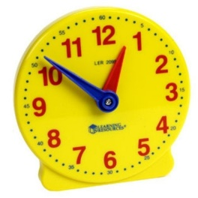 | Math / Literacy Integration  You have been learning how to tell the time on a clock. Now it’s time to apply it to your real life!  Make a table showing what time you do activities today.
What time is it? |  | What did you do?

