STAR Reading & Math Tests - RENLearn Website Log In Details
We use these tests at regular intervals across the year to help track their progress. Once your child is logged in, the questions are timed. If you have any problems accessing either test, please email Mrs Wade or Mrs Every.
The Reading Test measures how fluently your child can read and their comprehension. There are 35 questions in total. Please do not help them with the reading as it must be independent to get an accurate result. At this stage of the year, some children are reading fluently and some are still practicing, it may take your child up to 45 minutes to complete this test or they may be done in 15 minutes. If your child has finished in less than 10 minutes, it is likely that they have not read all the questions carefully and will need to redo the test. Mrs Wade will let you know about this.
The Math Test - there are 35 questions in total. You can help them with the reading. Remember that we are only part way through the year and so some topics may not have been covered yet. The questions will become progressively harder as the child answers correctly. Please do not worry if some questions seem too hard as some will be purposely too difficult to answer right now. With an adult reading the questions, it should take approximately 10-15 minutes to complete, however, please do not help them to solve the question.
Step 1: Copy and paste this link into your internet browser: hosted241.renlearn.com/296

Step 2: Click on “I’m a Student”

Step 3: To login, type the first letter of your child’s first name and the first four letters of their surname. For example, Joe Bloggs would be: jblog (If you cannot log in, try adding the number 1 at the end of their name: jblog1). The password for all children is: fbcs. Then click ‘Log In”.
Username

Password
Log In

Step 4: Click on “Take a Reading Test” or “Take a Math Test” from the blue boxes on the left-hand side of the screen.
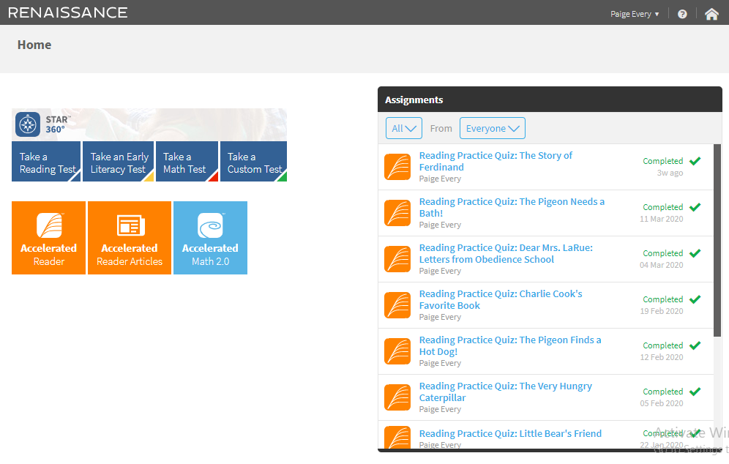

Step 5: The monitor password is: admin. Then click “Start”.

Note: Sometimes in school, some questions had a problem loading correctly. If this happens at home, just click on the ‘Stop Test’ button in the top right corner and then click ‘Cancel’ in the pop-up box. This should sort the problem out.

