Grade 1 Spanish
Week of April 20-24
Las partes del cuerpo review
To number the body parts in Spanish we say: Yo tengo (I have)…:

Yo tengo dos ojos. I have 2 eyes.
Yo tengo una nariz. I have a nose.
Yo tengo un estómago. I have a stomach.

To number just one body part we use: un or una
We use un when the word ends in o
We use una when the word ends on a, z, ect…
Step 1 | Complete the drawing with the body parts that are missing and color in.

If you have any questions, please email Mrs. Powell: FPowell@fbcs.edu.ky

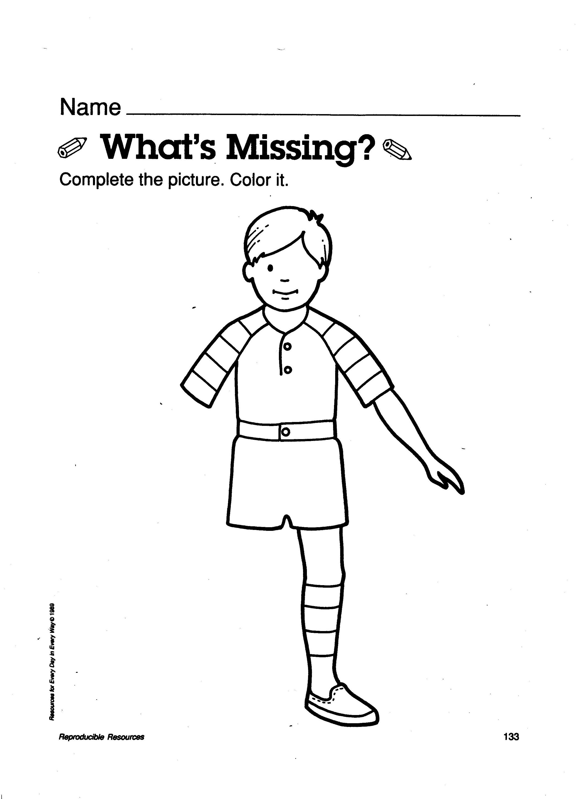
Nombre:___________________
Le falta:
Un ojo
un brazo
una pierna

