**Reading for Thursday’s Bible Lesson:** Acts 16:1-3 and 2 Timothy 1:3-6

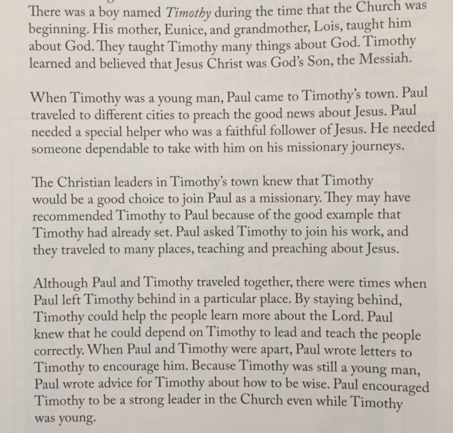

**Reading for Friday’s Bible Lesson**

