Grade 1 Spanish Week June 1st-5th Lesson 1
Cultura
El flamenco
OBJECTIVE | ACTIVITIES | RESOURCES
To learn what flamenco is and where originally is.  To learn visually how you dance it. | ACTIVITY 1:  Pray with Mrs. Powell and sing the song, Buenos días.  Click this link: https://youtu.be/weLITQ0Jjc0  ACTIVTY 2:  Click this link https://youtu.be/Xwyj0Z2AvvM and watch how flamenco is danced.  ACTIVTY 3:  Read with Sra. Powell “El flamenco”  ACTIVTY 4:  Color the pictures of Spain and the Flamenco dancers.  ACTIVTY 5:  Color the drawing. Once work is completed, parents take a picture and send it to Mrs. Powell’s email address: FPowell@fbcs.edu.ky  In case you can’t print the document, please draw the pictures and color them.  Dios les bendiga | Computer/device  Access to internet

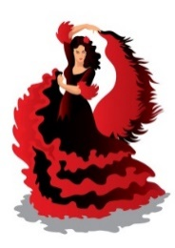
Nombre:__________________
El flamenco

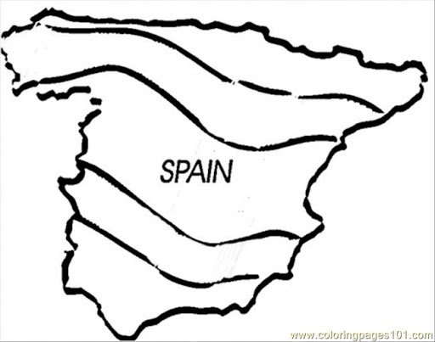 | 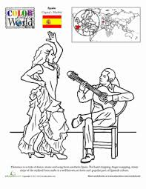

El flamenco es una música folclórica de España, originaria de Andalucía.
Es un arte que tiene tres partes fundamentales; guitarra, cante y baile
Es un arte que expresa muchos sentimientos profundos

Flamenco is a folk music from Spain, it is originally from Andalusia.
It is an art that has three fundamental parts; guitar playing (“guitarra”), song (“cante”) and dance (“baile”).
It is an art that expresses different deep feelings and emotions.

Grade 1 Spanish Week June 1st -5th Lesson 2
Cultura
El flamenco
OBJECTIVE | ACTIVITIES | RESOURCES
To learn what flamenco is and where originally is.  To learn visually how you dance it.  To know what the instruments are used for “el flamenco”. | ACTIVITY 1:  Pray with Mrs. Powell and sing the song, Buenos días.  Click this link https://youtu.be/k-d6duAZvKU  ACTIVTY 2:  Click this link https://youtu.be/ncPPVha9T6c to see the video dancing flamenco.  ACTIVTY 3:  Read the information about “el flamenco” with La Sra. Powell.  ACTIVTY 4:  Color the drawing. Once work is completed, parents take a picture and send it to Mrs. Powell’s email address: FPowell@fbcs.edu.ky  In case you can’t print the document, please draw the pictures and color them.  Dios les bendiga | Computer/device  Access to internet

Nombre:__________________

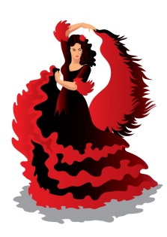
El flamenco

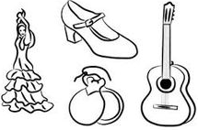

El flamenco es un arte que se expresa en la música y el canto.
El flamenco se baila golpeando los pies en el piso (golpe), con las manos puedes hacer sonidos, gestos (floreo) y palmas.
Si eres una niña, necesitas un vestido largo con una cola ancha, también necesitas accesorios como flores en el cabello también puedes usar un abanico.
Para hacer la música necesitas una guitarra, un cajón, palillos.

Flamenco is an art that is represented in the music and singing.
Flamenco is danced striking the floor with your feet, you can make sounds, gestures and claps with your hands.
If you are a girl, you need a long dress with a wide tail, you also need accessories like flowers in your hair, you can also use a hand fan.
To make the music, you need a guitar, a wood box and “palillos”.

