U.S.A. Money – Coins
There are 100 cents in $1
Amount | Front and Back
1 Penny=  1₵ | 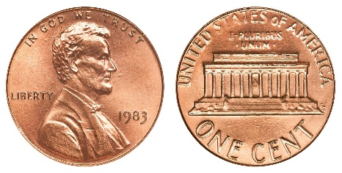
1 Nickel=  5₵  (both might be seen) | 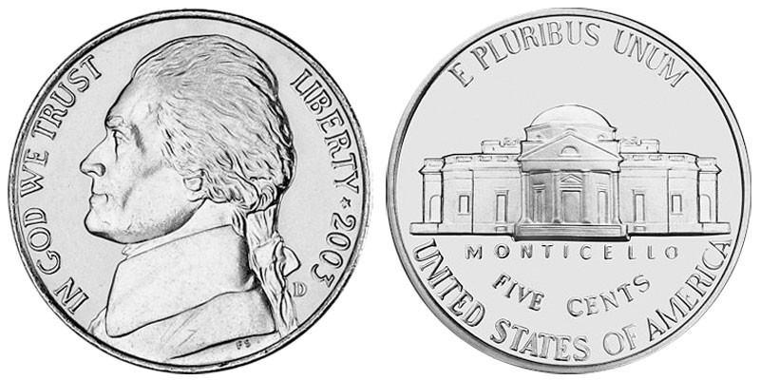  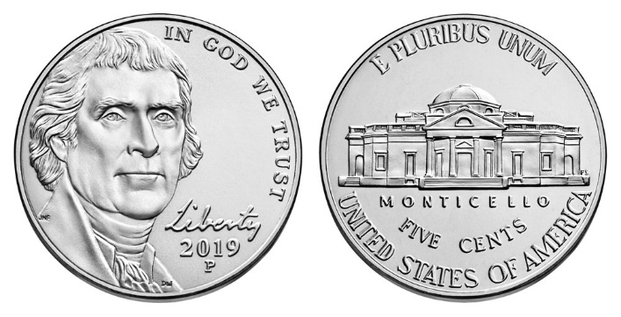
1 Dime=  10₵ | 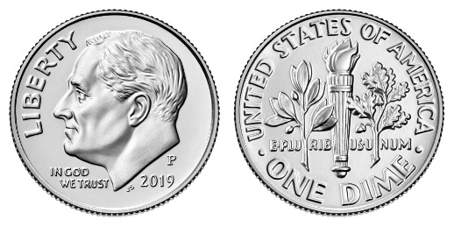
1 Quarter =  25₵ | 