Grade 1 Spanish Week June 15th -19th Lesson 1
Cultura “las fiestas de San Fermín
OBJECTIVE | ACTIVITIES | RESOURCES
To know about Spanish culture.  To identify words from the reading about “San Fermin” | ACTIVITY 1:  Go to YouTube by clicking the link (https://youtu.be/LXzAKxJ6aUc) and watch the video about San Fermin Festival, the video is in Spanish. Please make sure to turn on the subtitles to be able to read it for your child.  ACTIVITY 2:  Go to the link (https://youtu.be/MA3aHUE2SSs) and pray with Sra. Powell  ACTIVTY 3:  Read “San Fermin festival” with Sra. Powell  ACTIVTY 4:  Color the picture about San Fermin Festival, take a picture and upload it on Seesaw or send it to Sra. Powell’s email: FPowell@fbcs@edu.ky  Dios les bendiga | * Computer or device.  * Access to internet

Lesson 2:
Log in to Grade 1 Zoom on Wednesday June 17 for a live Spanish lesson with Sra. Powell

San Fermín Festival
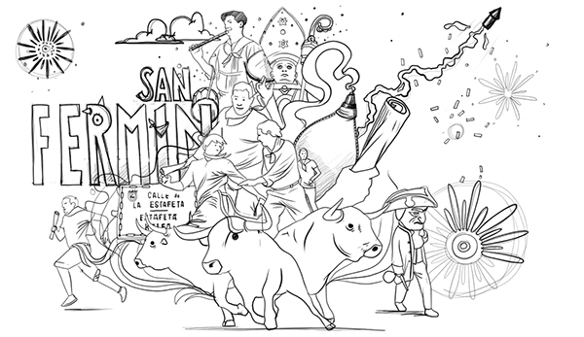

Las fiestas de San Fermín se celebran en Pamplona en el norte de España todos los años del 6 al 14 de julio.
Las fiestas son conocidas internacionalmente por la celebración del encierro.
El encierro es una carrera en la que los toros corren por las calles de la parte vieja de la ciudad.
Las fiestas son en honor a San Fermín el patron de Navarra.

San Fermin Holiday are celebrated in Pamplona in the North of Spain every year from the 6th to the 14th of July.
The festival is known internationally for the celebration of the « Encierro ». It is a race where the bulls run along the streets in the old part of the city.
The festival is celebrated in honor of San Fermín, the saint of Navarra.

