Categories for FBCS Science Fair
- MODELS – students can build a model to show a scientific principle. Example, a model of a simple machine (crane, a well etc.); robotic arm with hydraulics; a plant cell, a heart and so on.

- ENGINEERING-things that move - Students will display structures that they have built that allows and object to move. Example, a marble run, a water flow, a roller coaster, a combination of machines that move an object from one place to the next and an automata. In this category both parent and child can team up in building the project. However, the child must be the one that explains how it works and what scientific principles are at work.
See some examples below.
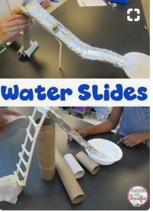
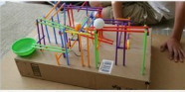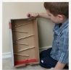
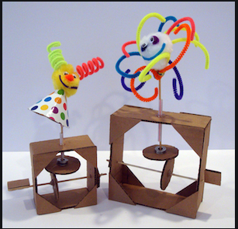
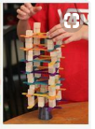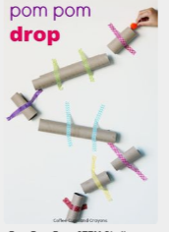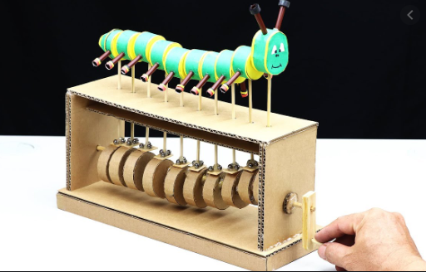

- DEMONSTRATIONS of science experiments. The student/s should be able to explain the science of how it works.
- SCIENTIFIC PROCESS/Science Fair experiments- these are experiments with clearly identifiable variables (independent, dependent and controlled) The best in this category will have the option of entering the Rotary Science Fair.

The gym will be divided into sections mentioned above rather than by grades. Classes will be rostered to view the displays as shown below.
SET UP TIME: 10-11AM
JUDGING: GRADES K-2 – 11AM TO 11:30AM ( 5 judges)
GRADES 3-6—11:30 TO 12:00PM ( 5 judges)

12:20-12:40 Grades: K and 1
12:40-1:05 Grades: 2 and 3
1:05-1:30 Grade: 4
1:30-1:55 Grade: 5
1:55- 2:20 Grade: 6
2:20-2:45 pack up

