El tiempo vocabulary
¿Qué tiempo hace?: What is the weather like?
Está nevando: it is snowing
Está lloviendo: it is raining
Está nublado: it is cloudy
Hay neblina: it is foggy
Hay viento: it is windy
Hace sol: it is sunny
Hace frío: it is cold
Hace fresco: it is cool
Hace calor: it is hot
El cielo está despejado: the sky is clear
Hay una tormenta: there is a storm
Hay un huracán: there is a hurricane
Hay un tornado: there is a tornado
Hace mal tiempo: bad weather
Hace buen tiempo: good weather
Hay truenos: there are thunders
Hay relámpagos: it is lightning

Listen to the word the teacher says and circle the correct picture that corresponds to the Spanish meaning.
Nombre:__________________________
Fecha:___________________________

- A B C

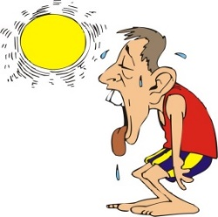
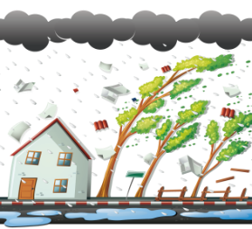
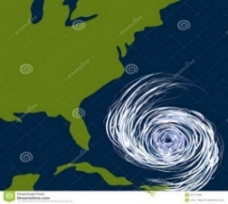

2. A B C
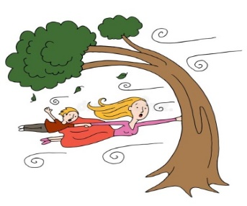

- A B C
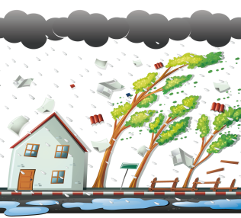

4. A B C

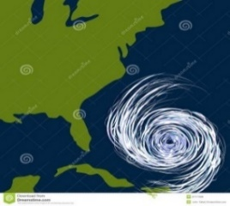

5. A B C

Grade 2 Spanish – week of March 30 – April 3rd lesson 2.
El tiempo, listening activity
Lesson Objective | The students will be able identify the words from the vocabulary “el tiempo” by listening.
Supplies | Vocabulary and listening activity paper.
 | Computer/Phone with Internet
Vocabulary | ¿Qué tiempo hace?: What is the weather like?  Está nevando: it is snowing Está lloviendo: it is raining  Está nublado: it is cloudy Hay neblina: it is foggy  Hay viento: it is windy Hace sol: it is sunny  Hace frío: it is cold Hace fresco: it is cool  Hace calor: it is hot El cielo está despejado: the sky is clear  Hay una tormenta: there is a storm Hay un huracán: there is a hurricane  Hay un tornado: there is a tornado Hace mal tiempo: bad weather  Hace buen tiempo: good weather Hay truenos: there are thunders  Hay relámpagos: it is lightning
Step 1 | Watch video from youtube: https://youtu.be/ZZDraJ32Dhs  Repeat the words form the vocabulary after the teacher.
Step 2 | Without looking at the vocabular listen to the words the teacher will say and then circle the correct pictures that matches with the word in Spanish she says.  In case you can’t print the document write the number of the question and then write the correct letter in a papper.  Example:  1 (B)  2 (c )
Mrs. Powell email: FPowell@fbcs.edu.ky

