El tiempo vocabulary
El tiempo: weather
¿Qué tiempo hace?: What is the weather like?
Está nevando: it is snowing
Está lloviendo: it is raining
Está nublado: it is cloudy
Hay neblina: it is foggy
Hay viento: it is windy
Hace sol: it is sunny
Hace frío: it is cold
Hace fresco: it is cool
Hace calor: it is hot
El cielo está despejado: the sky is clear
Hay una tormenta: there is a storm
Hay un huracán: there is a hurricane
Hay un tornado: there is a tornado
Hace mal tiempo: bad weather
Hace buen tiempo: good weather
Hay truenos: there are thunders
Hay relámpagos: it is lightning
¿Qué tiempo hace hoy?

Nombre:___________________
(What is the weather like today?)

Está nublado hoy. No hay sol hoy. Hay nubes grises en el cielo. Parece que va a llover.
It is cloudy today. There is not sun today. There are gray clouds in the sky. It looks like it is going to rain.

Nombre:______________________
Write the correct letter bellow each picture.
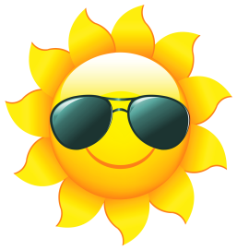
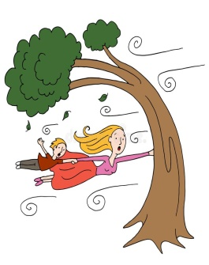

A. está lloviendo B. Está nublado C. Hace frío

D. Hace viento E. Hace sol F. Hace fresco

G. Hay neblina H. Está nevando

Grade 2 Spanish – Week of March 23 – 26 1st lesson
El tiempo “está nublado”
Lesson Objective | To learn at least 5 words from the vocabulary
Supplies | Vocabulary “el tiempo”, bingo “el tiempo” ¿Qué tiempo hace hoy?  printed or be able to see on a device
 | Computer/Phone/ tablet with Internet
Vocabulary | El tiempo: weather, ¿Qué tiempo hace?: what is the weather like?, está nublado: it is cloudy, hoy: today, hay: there is/are, nubes: clouds, grises: gray, cielo: sky, parece: it looks like, va a llover: it is going to rain.
Step 1 | Review vocabulary “el tiempo”
Step 2 | Read the Spanish and English part of the paper or device.
Step 4 | Make a drawing of the reading describing the weather.
Step 5 | Write the correct letter from the word bank bellow each picture.

Mrs. Powell email: FPowell@fbcs.edu.ky

