TECHNOLOGY
OBJECTIVES | ACTIVITIES | RESOURCES
- To be able to work within Microsoft Word and add text and images | PRIOR KNOWLEDGE:  - Research images on the internet  - Copy and paste images  - Type text  - Open a word document  - Save a document  ACTIVITY:  - Think of five snacks you like to eat  - Erase the snacks in my document and add your own  - Find images of your snacks online, copy the images and paste them next to your sentences  - STEPS:  - Open the Five Snacks document  - Backspace my snacks and add your own  - Go onto the internet and search for your snacks  - Copy an image by right clicking on it and clicking copy image  - Paste the image next to your sentence by right clicking and clicking paste (or the little clipboard icon)  - Once completed – please email your document to me to assess  - My email is: kirstenanthony0@gmail.com | - Computer / Device  - Microsoft Word  -Five Snacks Document  -Internet access

5 Snacks I Like
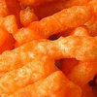
I like Cheetos.
I like Fruit Roll Ups.
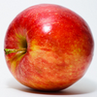
I like Apples.
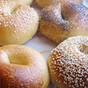
I like Bagels.
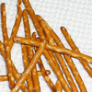
I like Pretzels.

By: Robert

