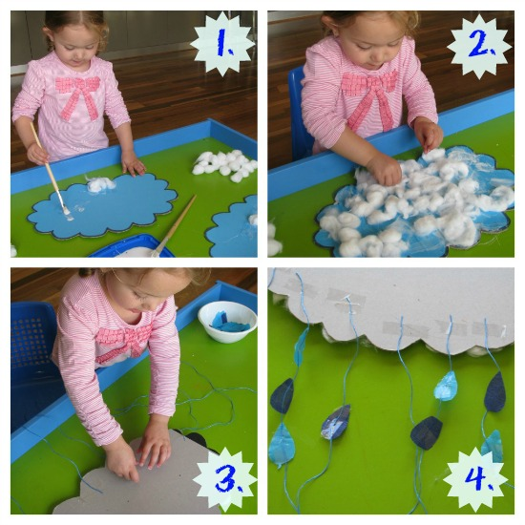
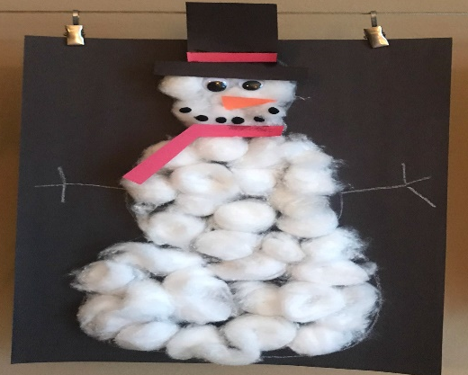

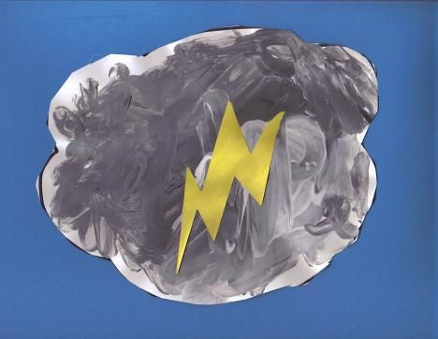
Garde 2 Spanish– Week of April 6-8
El tiempo
This art craft will be used to decorate the classroom. Please keep it for when we come back to school.

Hace sol | Color a paper plate on yellow draw a face. Cut out yellow colored paper in triangle shapes and glue them as shown on the picture.
Esta lloviendo | Use blue colored paper to make the shape of the cloud, glue some cotton or toilet paper on the cloud shape paper. Stick on some yarn and glue on it some drops made of colored paper as it is on the picture.
Esta nevando | Use cotton or pieces of toilet paper or tissue paper to form the snow man. Use plush stick pom pom or colored paper for the scarf and black colored paper for the hat.
Hay truenos | With a white paper make the shape of a cloud and use gray crayon or color pencil and with colored paper make the shape of a thunder.
Hope you had fun!!
Mrs. Powell email: FPowell@fbcs.edu.ky

