Grade 2 Spanish – Week May 4-7 lesson 1
La ropa- yo llevo
OBJECTIVE | ACTIVITIES | RESOURCES
To know how to say I WEAR in Spanish in first, second and third person  To make sentences saying what I wear using the correct indefinite article and the verb to wear in first person. | ACTIVITY 1:  - Write in your Spanish book how to use the verb “llevar” in frist (I) second (you) and third person (he, she):  I wear : Yo llevo  You wear tú llevas  She weas ella lleva  He wears él lleva  In order to create sentences saying what I, you, she and he wear we write “yo llevo, tu llevas, el, ella lleva” which means I wear, you wear, she, he wears, and then the indefinite article and then the clothing.  Yo llevo un vestido  I wear a dress  ACTIVTY 2:  - Look at the sentences from next page and then pay attention.  Activity 3  Complete sentences by writing the correct form of the verb “llevar” and the correct indefinite article in Spanish.  Dios les bendiba | - Access to internet  -Device or computer

Look at the following sentences:

- Ella lleva una falda. She wears a skirt.
Remember that in order to create a correct sentence in Spanish, we need to write the correct form of the verb “llevar”, correct indefinite article and finish it with the clothing.
The correct form of the verb will depend on the subject (as I, you she, he or names)
The correct indefinite article depends on th clothing (noun) if it is feminine or masculine and if it is one or more than one.

- Él lleva unos zapatos. He wears some shoes.
- Mi mamá lleva unas sandalias. My mother wears some sandals. (in this sentence, we replaced my mother for she, so the verb will be “lleva”)
- Tú llevas un impermeable. You wear a raincoat.
- Sophia lleva una blusa. Sophia wears a blouse.

Complete the following sentences with the correct formo f the verb and the indefinite article, follow the example.
- Margot _lleva___ _una_____ camisa.

- Yo __________ _____ sombrero.

- Tú _________ _____ impermeable.

- Ella _________ _____ vestido.

- Él _________ _____ bufanda.

- Mi madre ___________ ______ zapatillas de deporte.

Grade 2 Spanish – Week May 4-7 lesson 2
La ropa- yo llevo
OBJECTIVE | ACTIVITIES | RESOURCES
To know how to say I WEAR in Spanish in first, second and third person  To make sentences saying what I wear using the correct indefinite article and the verb to wear in first person.  Review colors  Improve reading in Spanish. | ACTIVITY 1:  - Let’s remember the forms of the verb “to wear” in Spanish:  I wear : Yo llevo  You wear tú llevas  She weas ella lleva  He wears él lleva  ACTIVTY 2:  Let’s review colors in Spanish:  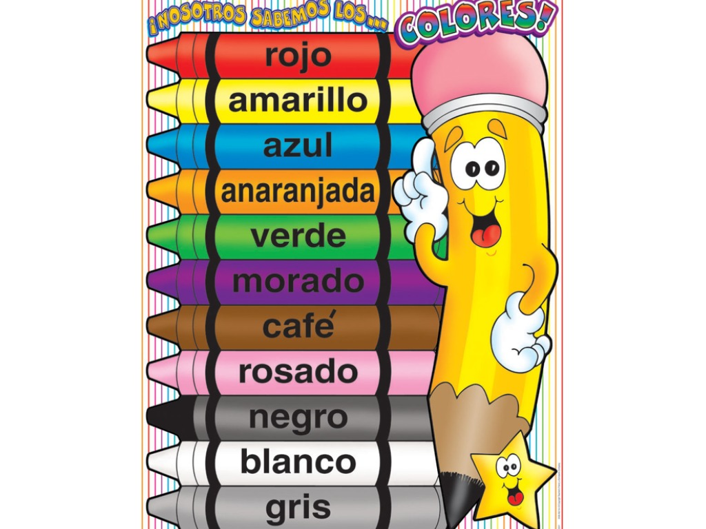  Activity 3:  Read the description of the clothing for each person and then depending on what they are wearing write the name of the person bellow each picture.  In case you can print the document write the number and the name of the person describided.  Once activity is completed, please send by email to Sra. Powell:  FPowell@fcbs.edu.ky  Dios les bendiba | - Access to internet  -Device or computer

Read the description of the clothing for each person and then depending on what they are wearing write the name of the person bellow each picture.
Nombre:____________________

- Hola soy Nadia, yo llevo un traje de baño blanco.

- Hola soy José llevo una gorra blanca y anaranjada.

- Hola soy Alejandro, yo llevo un sombrero marrón.

- Hola soy Fernanda yo llevo una chaqueta y una falda roja y una camisa blanca.

- Hola soy Mateo, yo llevo una camisa azul y unos pantalones cortos negros.

- Hoy soy María, yo llevo un vestido y unos zapatos rojos.
2
1.
_______________ ______________

3.
4
___________________ ___________________

6
5
____________________ _________________

