Good evening Parents,
We had a good week. The kids said their scripture verse for the week and have been doing better at remembering their vocabulary words in Science ( ecosystems, organism, population, community, terrestrial, aquatic, abiotic, biotic).
The Science target that students have worked on this week are :
- Being able to compare and contrast plants and animals that are found in land and water ecosystems.
- Giving names of major land and water ecosystems and giving examples of plants and animals that live there.
Please log on to Moby max for what we learnt during the week. Only do up to slide 11.
Here are some links to reinforce the learning in class.
http://studyjams.scholastic.com/studyjams/jams/science/ecosystems/biomes.htm
http://studyjams.scholastic.com/studyjams/jams/science/ecosystems/aquatic-ecosystems.htm
In Math students learnt rounding whole numbers to the nearest 10 and 100. They will have to go further and round to the nearest 1000 this coming week. Two strategies were used. One which used a number line and the other which followed a rule.
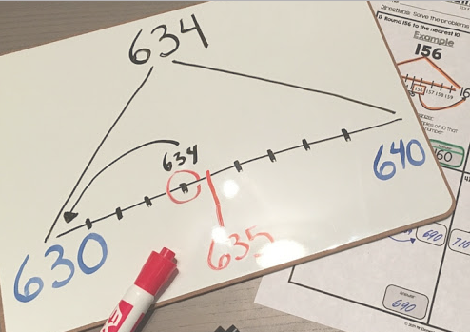
Using a number line 634 rounds to 630
What was clear is that most students need practice counting in hundreds and thousands. Example what comes next after 3, 457 until the next ten (3, 460). Please practice in the car. Maybe start of with a number in the hundreds and ask your child to count forwards up to the nearest 10 or 100 and then backwards.

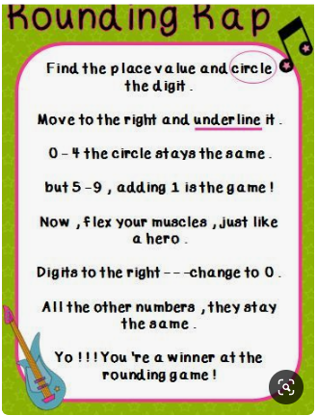
Using a rule
Social Studies
- The students will be starting a new unit in Social Studies. They would be exploring the wonders of being a Grand Cayman.

Literacy
- In Literacy, the students will be focusing on comprehension and writing statements and questions. Students will strengthen they comprehension and understanding skills by reading short stories and figuring out key components or ideas within. The spelling words would be sent home on Monday 23rd September, 2019. Please encourage students to read at least 15 minutes a day at home.

