Third Grade Daily Home Learning Grid – Friday March 19, 2020
BIBLE | Lesson Objective | Activities | Links | Resources
Friday  March 20 | To identify ways that you can glorify GOD | Lazarus lives: lesson 3  Lets do something fun today. How about you make a model of the tomb and Lazarus coming to life. You can also choose to draw the scene in seesaw as well.  If you are making a model it might look like this  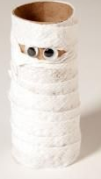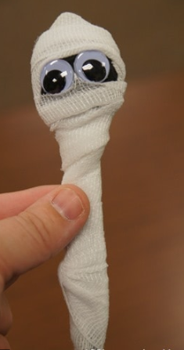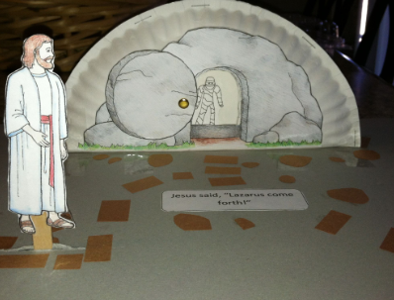 | You can look up images of DIY lazarus | Access to internet  Screen  Plastic spoon or empty paper roll. Scrap material to wrap around.  Paper plate or cardboard or empty box.

MATH | Lesson Objective | Activities | Links | Resources
Friday  March 20 | To practice finding area and perimeter | Today you will practice developing your skills in area and perimeter.  In seesaw do the activity on area and perimeter and then do the mathletics assigned on this. | Seesaw  https://web.seesaw.me/  Mathletics:  https://www.mathletics.com/us/ | Access to internet

SCIENCE | Lesson Objective | Activities | Links | Resources
Friday  March 20 |  | NO SCIENCE TODAY

LITERACY | Lesson Objectives | Activities | Links | Resources
Friday March 20 | To write an opinion essay using prompts. | - Students will look through the list of Opinion Writing Prompts provided below and choose a topic of interest.  - Students will then complete the graphic organizer given below using their topic. | See attached documents

Opinion Essay Writing Prompts
When writing an opinion essay, students should clearly state their opinion, then back it up with sound reasons and facts. Opinion essays should close the essay with a concluding paragraph and a summary of the argument.
- Be a Friend. What does it mean to be a good friend?
- Growing Up or Down. Would you rather be older than you are right now or younger? Why?
- Hello? Some kids in 3rd grade have cell phones. Do you? Do you think that’s good or bad?
- Best Pets. Which animal makes the best pet? Give at least three reasons for your opinion.
- Tattletale. If you saw one of your friends doing something that you knew was wrong, should you tell on them? Why or why not?
- School Favorites. What do you think is the best subject in school? What makes it the best?
- Off Limits. Is there a TV show that you’re not allowed to watch or a video game that you’re not allowed to play? Explain why your parents should allow it.
- Summer School. Should your school be in session year ‘round with more breaks throughout the year or continue to give students the summer off? Why?
- Violent Games. Do violent video games cause people to exhibit violent behavior? Support your opinion.
- Junk Food Fans. Should candy and soda machines be available to students on school property? Why or why not?
- School Supplies. What is the most important tool in your classroom? What makes it so useful?
- School Pride. What is the best thing about being a student at your school?
- What’s in a Name? If you could change your name, what would you choose and why?

Opinion Writing Graphic Organizer
Topic: __________________________________

Firstly, Secondly, Finally
Reason #3:
________________________________________________________________________________________________________________________________________________________________________________________________________________________Example:
________________________________________________________________________________________________________________________________________________

Reason #2:
________________________________________________________________________________________________________________________________________________________________________________________________________________________Example: ________________________________________________________________________________________________________________________________________________

Reason #1:
________________________________________________________________________________________________________________________________________________________________________________________________________________________Example: ________________________________________________________________________________________________________________________________________________
Conclusion: _______________________________________________________________________________________________________ ______________________________________________________________________________________________________________________________________________________________________________________________________________________________________________________
In closing, In conclusion
Next, then, also, too
Transition Words
Introduction Sentence (In my opinion, I strongly believe, __________________________________________________________________________________________________________ ______________________________________________________________________________________________________________________________________________________________________________________________________________________________________________________

