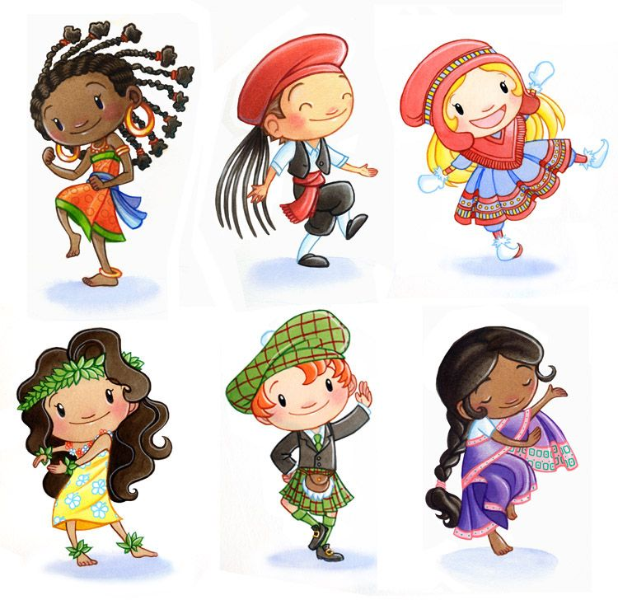
Las nacionalidades
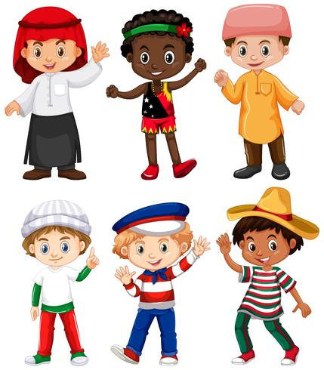

Vocabulario 1 los países:
Inglaterra: England Japón: Japan Irlanda: Ireland México: Mexico España: Spain Cánada: Canada
Escocia: Scotland Jamaica: Jamaica Islas Caimán: Cayman Islands Los Estados Unidos: United States África: Africa Alemania: Germany Las Filipinas: Philippines
Honduras: Honduras Nicaragua: Nicaragua Francia: France
Perú: Peru Italia: Italy Rumania: Romania Indonesia: Indonesia

Vocabulario 2 Las nacionalidades:

English: inglés/ inglesa Japanese: japonés/japonesa
Irish: irlandes/ irlandesa Mexican: mexicano/mexicana
Spanish: español/española Canadian:cánadiense
Scottish: escocés/escocesa Jamaican: jamaicano/jamaicana
Caymian: Caimanero/caimanera American: estadounidense African:africano/africana German: alemán/alemana
Philippine:filipino/filipino Honduran: hondureño/hondureña
Nicaraguan: nicaragüense French: francés/francesa
Peruvian: peruano/peruana Italian: italiano/italiana
Romanian: rumano/rumana Indonesian: indonesio/indonesia

Nombre:____________________
Irlanda

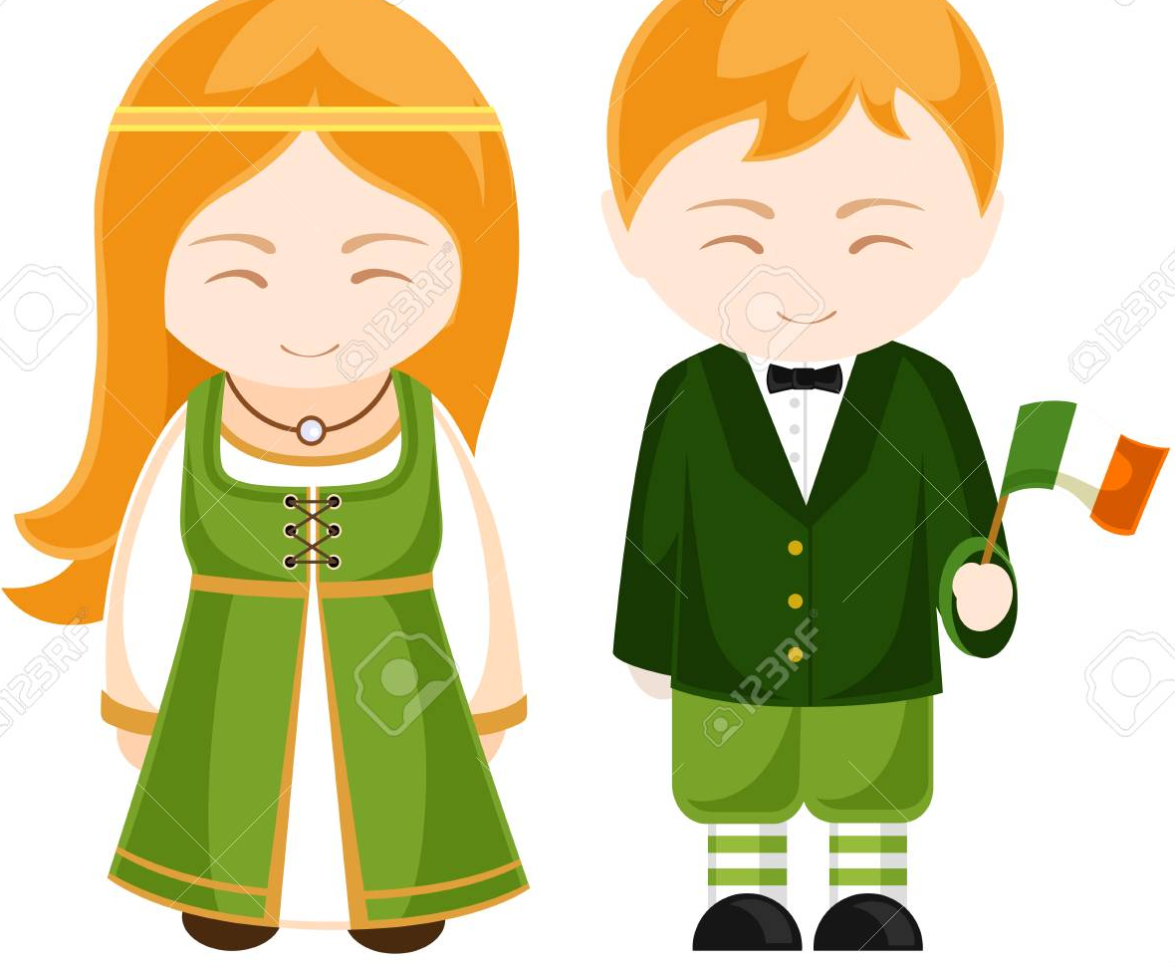

Nosotros somos de Irlanda. Somos irlandeses. We are from Ireland, we are Irish.
Nosotros vivimos en Irlanda. We live in Ireland.
Irlanda está situado en Europa. Ireland is situated in Europe.
Una de nuestras fechas más importantes es el día de San Patricio. One of our most important dates is the Saint Peter day.
Nombre:___________________________
Fecha:_____________________________
Write the nationality in Spanish.

Yo soy _______________________________

Nicaragua
Él es ________________________________

Indonesia

Ella es_______________________________

Japan
Él es__________________________________

Ireland
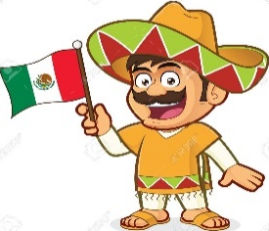
Yo soy _____________________________

Mexico

Grade 3 Spanish – Week of March 18 - 20
Las nacionalidades “Inglaterra”
Lesson Objective | To know by heart at least 10 words from the vocabulary we have been practicing.  To say the nationalities of different people, identifying when to add “a” or no add any change to the Word depending on the gender of the person and the nationality.
Supplies | Vocabulary los países and las nacionalidades and the Reading Ireland printed or be able to see on a device
 | Computer/Phone/ tablet with Internet
Vocabulary | Inglaterra: England, Japón: Japan, Irlanda: Ireland, México: Mexico, España: Spain, Cánada: Canada, Escocia: Scottland Jamaica: Jamaica, Islas Caimán: Cayman Islands, Los Estados Unidos: United States, África: Africa
Introduction | Go to www.quizlet.com using this link https://quizlet.com/join/DSAZ5Zk3P and learn and practice the vocabularies in a fun way.
Step 1 | Take your time and review the words for both vocabularies.
Step 2 | Read and translate the page about “Irlanda”  From the worksheet or the device.
Step 3 | Color the page (If cannot print the page, make a drawing like this one and color.)
Step 4 | Look at the pictures and write the nationality. Remember that the word will change if the nationality ends in “O” and the person is a female. In case the nationality ends in “e” it remains the same for both female and male.

