Third Grade Daily Home Learning Grid – Thursday March 18, 2020
BIBLE | Lesson Objective | Activities | Links | Resources
Wednesday  March 18 | To identify ways that you can glorify GOD | Lazarus live: lesson 2  You have looked at the story so now read the story in the bible. Go John 11: 1-44 and then answer the questions in the worksheet on Lazarus which is posted in seesaw. | Seesaw  https://web.seesaw.me/ | Access to internet  Screen  Bible student book  Pencil

LESSON PLAN: Parent and student friendly version
MATH Thrs. March 19
MATH: Perimeter
Yesterday we completed patterns and you will be given an online practice test on patterns and functions on Monday 22 March.
What will I be able to do when I finish today’s lesson?
Today you will be able to determine the perimeter of various polygons.
What is important for me to learn and understand so that I can use this to do it?

-I must know what is a polygon. (It is a plane figure formed by straight lines)
-I must be able to know what perimeter means.
- I must know that to find perimeter, I must add the distance around the polygon.
-I must be able to add the distance around a polygon to determine perimeter.
Look at these two videos:
https://www.khanacademy.org/math/basic-geo/basic-geo-area-and-perimeter/basic-geo-perimeter/v/introduction-to-perimeter
https://www.khanacademy.org/math/basic-geo/basic-geo-area-and-perimeter/basic-geo-perimeter/v/perimeter-of-a-shape

How can I show that I can do it?
- After looking at the video on Khan’s academy explain to an adult at home how perimeter is found.
- Practice finding perimeter by clicking on the practice links on the video on the left hand side( see blue arrows)
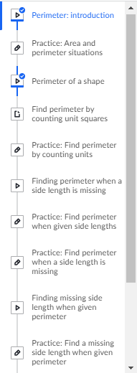
Advanced students
All students

What to look for to know I did it well? (success criteria)
I can accurately answer questions in Ready Math instruction workbook- page 316 Q1 and 3; page 317 Q 4.
I can build a structure with my lego blocks to show perimeter. See seesaw activity for instructions.
If you do not have lego blocks you can draw shapes using this website:
https://print-graph-paper.com/virtual-graph-paper
let your parents have a look to make sure you are correct.

Literacy
Objectives:
Upon completion of this lesson the student will be able to...
- Identify verbs in the future
- Form the future of irregular verbs
- Combine sentences by joining predicates
Lesson:
- Students will using this link to watch a video on future tense verbs.
  - https://www.youtube.com/watch?v=fjLmsqB_fGk
- Student will then complete page 46-47 in their English workbook.
- Students will then read the instructions on pages 48 and 49 (writing with verbs), then proceed with the questions.
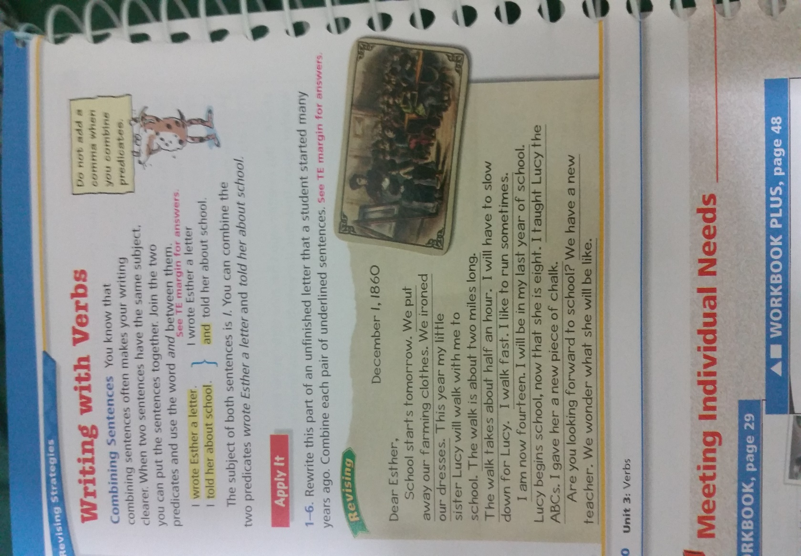
Assessment:
- Completing pages 46-49 in workbook.

