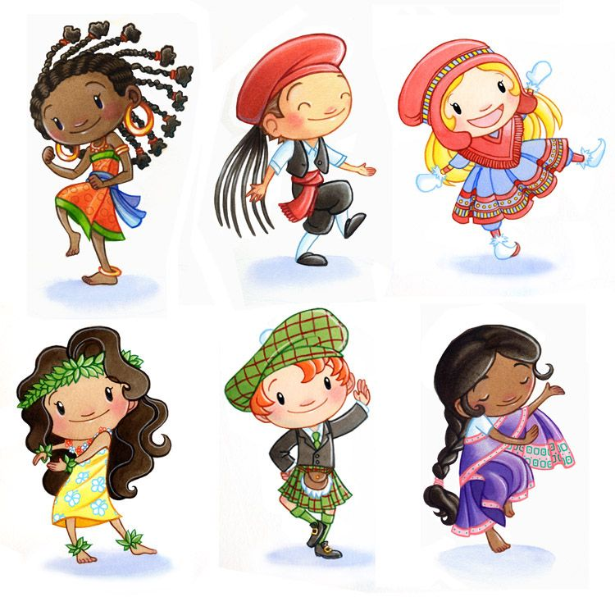
Las nacionalidades
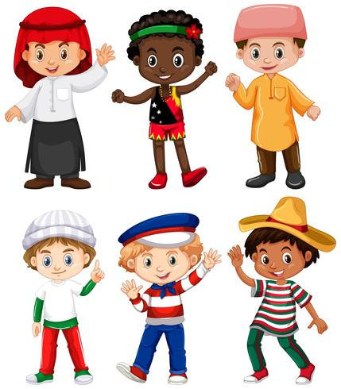

Vocabulario 1 los países:
Inglaterra: England Japón: Japan Irlanda: Ireland México: Mexico España: Spain Cánada: Canada
Escocia: Scotland Jamaica: Jamaica Islas Caimán: Cayman Islands Los Estados Unidos: United States África: Africa Alemania: Germany Las Filipinas: Philippines
Honduras: Honduras Nicaragua: Nicaragua Francia: France
Perú: Peru Italia: Italy Rumania: Romania Indonesia: Indonesia

Vocabulario 2 Las nacionalidades:

English: inglés/ inglesa Japanese: japonés/japonesa
Irish: irlandes/ irlandesa Mexican: mexicano/mexicana
Spanish: español/española Canadian:cánadiense
Scottish: escocés/escocesa Jamaican: jamaicano/jamaicana
Caymian: Caimanero/caimanera American: estadounidense African:africano/africana German: alemán/alemana
Philippine:filipino/filipino Honduran: hondureño/hondureña
Nicaraguan: nicaragüense French: francés/francesa
Peruvian: peruano/peruana Italian: italiano/italiana
Romanian: rumano/rumana Indonesian: indonesio/indonesia

Spain | 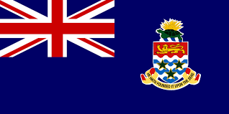  Cayman | 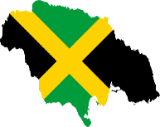  Jamaica | 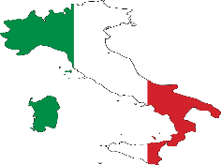  Italy
Philippine | 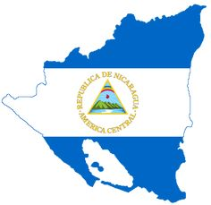  Nicaragua | Mexico | 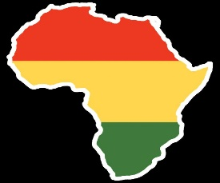  Africa
Ireland | 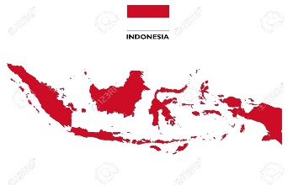  Indonesia | 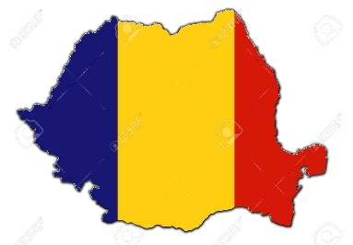  Romania | 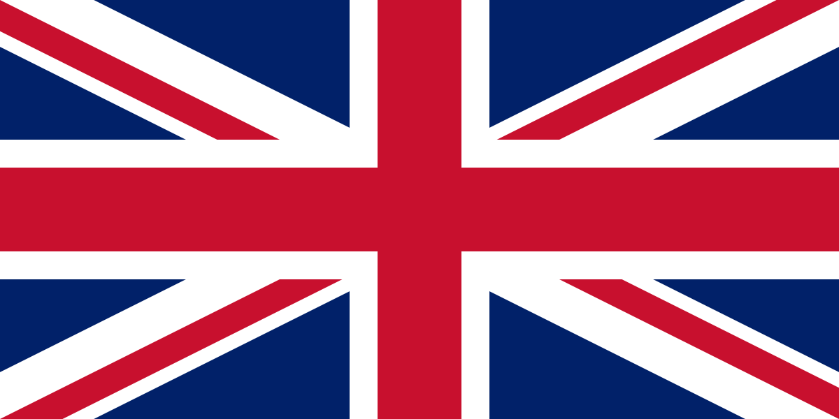  England
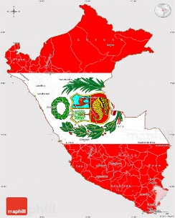  Peru | 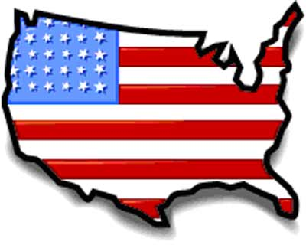  United States | 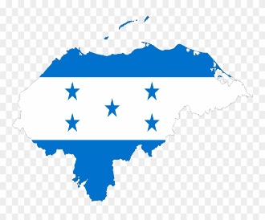  Honduras | 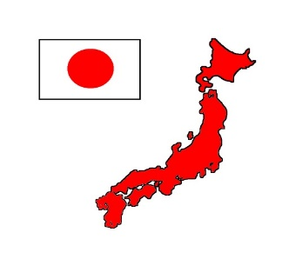  Japan
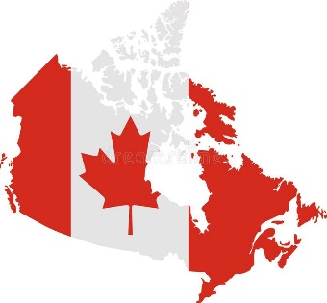  Canada | 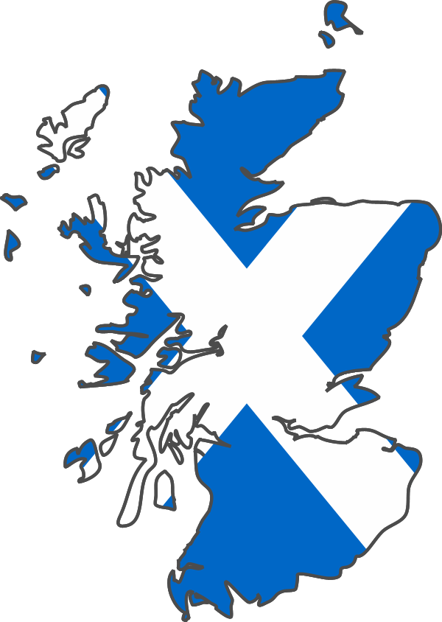  Scotland | 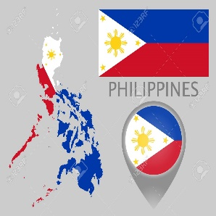  Philippine | 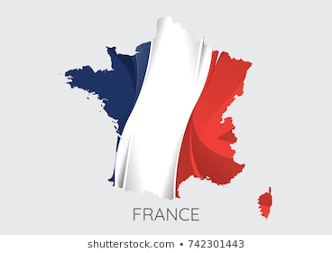  France
Bingo Los países

Read and color.
Nombre:__________________________________
Fecha:____________________________________
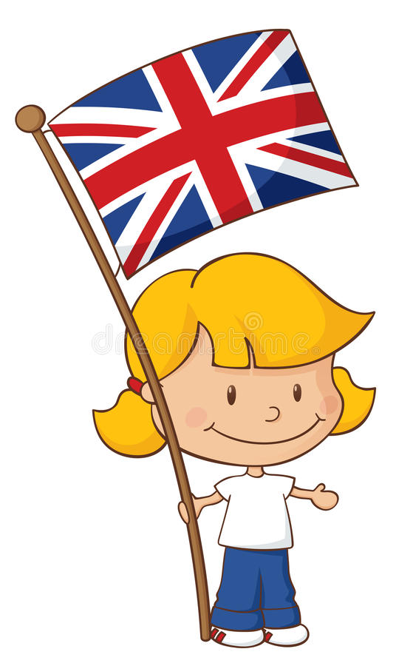
Inglaterra

Yo soy inglesa, soy de un país de Europa. I am English, I am from a European country.
Yo vivo en Inglaterra. I live in England.
Mis padres son ingleses. My parents are English.
Me gustan las patatas fritas con pescado. I like fish and fries.

Complete with the missing word from the Reading.

Yo __________________ ______________. __________ de un país de Europa.
Yo _____________ en _____________________.
Mis padres _______________ _____________________.
Me ____________ las patatas fritas con pescado frito.

Grade 3 Spanish – Week of March 18 - 20
Las nacionalidades “Inglaterra”
Lesson Objective | To know by heart at least 10 words from the vocabulary we have been practicing.
Supplies | Vocabulary los países and las nacionalidades and the Reading Inglaterra printed or be able to see on a device
 | Computer/Phone/ tablet with Internet
Vocabulary | Inglaterra: England, Japón: Japan, Irlanda: Ireland, México: Mexico, España: Spain, Cánada: Canada, Escocia: Scottland Jamaica: Jamaica, Islas Caimán: Cayman Islands, Los Estados Unidos: United States, África: Africa
Introduction | Go to www.quizlet.com using this link https://quizlet.com/join/DSAZ5Zk3P and learn and practice the vocabularies in a fun way.
Step 1 | Play with the bingo card, cover the letters and then say the country aloud and uncover and see if you are correct
Step 2 | Read and translate the page about “Inglaterra”  From the worksheet or the device.
Step 3 | Color the page (If can not prin the page, make a drawing similar to this one and color.
Step 4 | Complete with the missing word from the Reading. In case you can’t print write the sentences and complete them in a piece of paper.
Mrs. Powell email: FPowell@fbcs.edu.ky

