Grade 3 Spanish – Week April 28-30 lesson 1
Los lugares de la comunidad (places of the community)
Introduction
OBJECTIVE | ACTIVITIES | RESOURCES
To learn the words from the new vocabulary  To know how to identify by listening at least 10 of the words from the vocabulary | ACTIVITY 1:  - Read aloud the words from the new vocabulary  - Study the words  Vocabulary:  Hay: there is/are La piscina pública: public pool  La estación de trenes: train station El estadio: stadium  El museo: museum El teatro: theater  El ayuntamiento: town hall La iglesia: church  La estación de bomberos: fire station La estación de policía/ la comisaría: police station El hospital: hospital  El museo de arte: art gallery La zapatería: shoe store  El restaurante: restaurant La joyería: jewelry shop  La cafetería: coffee shop La panadería: bakery  La agencia de viajes: travel agency El supermercado: supermarket La tintorería: drycleaner  La farmacia: pharmacy La biblioteca: library  La peluquería: beauty salón El banco: bank  La escuela: school El colegio: college  La universidad: university El cine: cinema  La pescadería: fish market La carnicería: butcher  La tienda: store La floristería: florist store  El puerto: seaport La gasolinera: gas station  La tienda de recuerdos: souvenir store El eropuerto: airport  ACTIVTY 2:  - Ask one of you family member to call the words from the vocabulary and then you mark the picture until you get a bingo!!  - In case you can’t print it, make drawings and have fun making it yourself.  ACTIVTY 3:  Complete assignment. Write under each picture the letter that correspond to the meaning in Spanish. If you can’t print, write the number for each picture and then the correct letter.  Once you complete it, upload on seesaw in the Spanish folder.  Dios les bendiba | - Access to internet  -Device or computer
Lugares de la comunidad vocabulary
Hay: there is/are
La piscina pública: public pool
La estación de trenes: train station
El estadio: stadium
El museo: museum
El teatro: theater
El ayuntamiento: town hall
La iglesia: church
La estación de bomberos: fire station
La estación de policía/ la comisaría: police station
El hospital: hospital
El museo de arte: art gallery
La zapatería: shoe store
El restaurante: restaurant
La joyería: jewelry shop
La cafetería: coffee shop
La panadería: bakery
La agencia de viajes: travel agency
El supermercado: supermarket
La tintorería: drycleaner
La farmacia: pharmacy
La biblioteca: library
La peluquería: beauty salon
El banco: bank
La escuela: school
El colegio: college
La universidad: university
El cine: cinema
La pescadería: fish market
La carnicería: butcher
La tienda: store
La floristería: florist store
El puerto: seaport
La gasolinera: gas station
La tienda de recuerdos: souvenir store
El eropuerto: airport

Bingo lugares de la comunidad

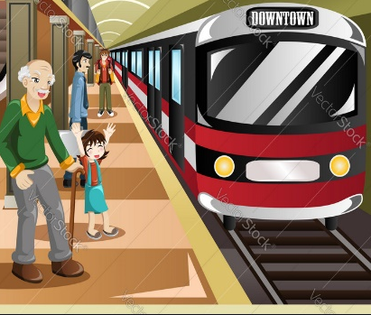 | 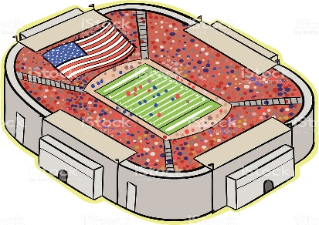
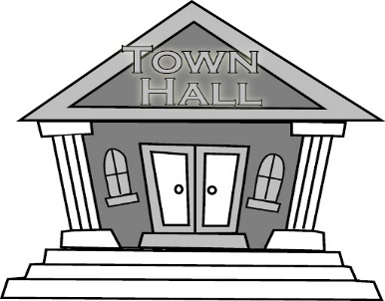 | 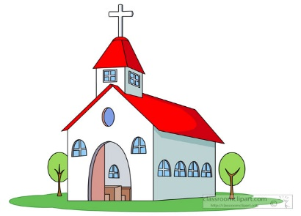 | 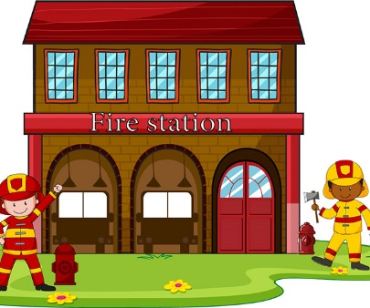 | 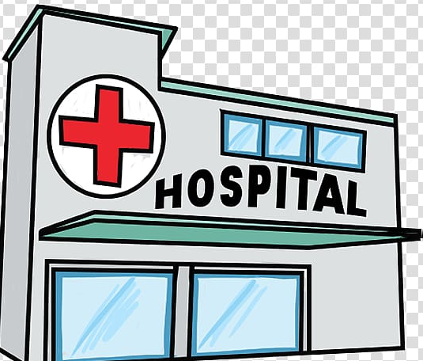
 | 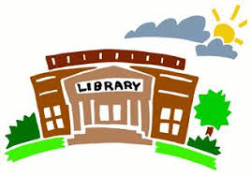 |  | 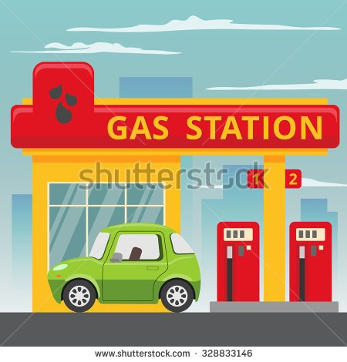

Nombre:______________________________________
Write under each picture the letter that correspond to the meaning in Spanish.
- El teatro
- El estadio
- El ayuntamiento
- El estadio
- La iglesia
- El aeropuerto
- La estación de bomberos
- El teatro
- La estación de policía/ la comisaría
- La panaderia
- El hospital
- La cafetería
1
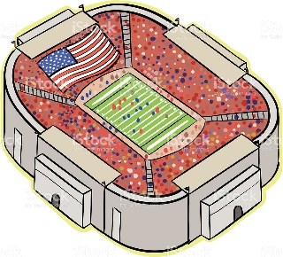
2
___________________ ________________________
3
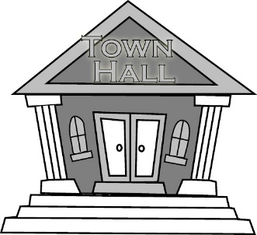
4
____________________ ________________________
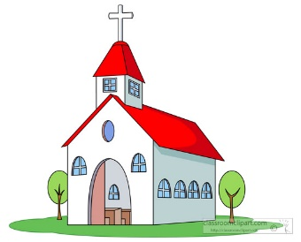
6
5
_____________________ __________________________
8
7
_______________________ _______________________
Grade 3 Spanish – Week April 28-30 lesson 1
Los lugares de la comunidad
OBJECTIVE | ACTIVITIES | RESOURCES
Know by heart at least 10 of the words from the vocabulary  To say the places from my community | ACTIVITY 1:  - Review the places of the community by looking at the bingo and name the places of the community you already know  ACTIVTY 2:  - Review the indefinite articles:  Indefinite articles in English: A, AN, SOME  Indefinite articles in Spanish: UNA, UN, UNAS, UNOS  - How do we use indefinite articles?  We use UNA when the Spanish word is feminine gender. The word is feminine when ends in “a” and the word is singular.  We use UN when the word is masculine gender. The word is masculine when ends in “o” or “e” and it is singular.  We use UNAS when the word is feminine, and it is plural.  We use UNOS when the word is masculine, and it is plural.  ACTIVTY 3:  - Ask to yourself the following questions:  - In what community do I live? Bodden Town, North Side…  - What places from the vocabulary are there in your community?  In order to answer in Spanish, when you are numbering the places you don’t say “uno” you use the indefinite article in Spanish, example:  Una libreria- a library  Un ayuntamiento- a townhall  - When you refer to more than one you can use the number, example:  2 iglesias  3 supermercados  ACTIVTY 4:  Translate the sentences to English.  Dios les bendiba | - Access to internet  -Device or computer

Pay attention to the follwing sentences:
- En mi comunidad hay una joyeria.
In my community there is a jewelry shop
- En mi comunidad hay un estadio.
In my community there is a stadium.

- En mi cumunidad hay 3 bancos.
In my community there is 3 banks.

- En mi comunidad hay un ayuntamiento.
In my community there is a townhall.

Translate to English:
- En mi comunidad hay 3 escuelas.
________________________________________________________________
- En mi comunidad hay una estacion de trenes
________________________________________________________________
- En mi comunidad hay una estacion de policias.
________________________________________________________________
- En mi comunidad hay 4 restaurantes.
________________________________________________________________
- En mi comunidad hay un hospital.
_______________________________________________________________

