LESSON PLAN: Parent and student friendly version date: March 23-26, 2020. 2nd lesson
Spanish class
Topic: La casa
What will I be able to do when I finish today’s lesson?
To say the parts of my house
To identify indefinite articles
To identify when to use “un” and “una” in Spanish
Practice the verb “tener”
What are the parts of house?
La casa house La sala de estar: living room La cocina: kitchen
El comedor: dining room La habitación: bedroom El patio: patio
El cuarto de baño: bathroom El ático: attic El pasillo: hall
La bodega:storeroom El portal: portal El jardín: garden
Garaje: garaje El sótano: basement El estudio/ el despacho: study/ office, La puerta: door El buzón: letter box La ventana: window
El techo: roof La chimenea: chimney Las escaleras: stairs La cerca: fence Hay: there is/ there are Tiene: has
El balcón: balcony La piscina: pool La sala de juegos: gameroom ¿Cuántos/as?: howmany
Assignments and resources
Go to Quizlet.com clicking this link https://quizlet.com/Francis_Ariana/folders/grade-4-spanish?x=1xqt&i=2qlfit to learn and practice the vocabulary.

Write the part of the house in Spanish beside the English word.

Write the parts of this house in Spanish beside the English word.
Nombre:________________________

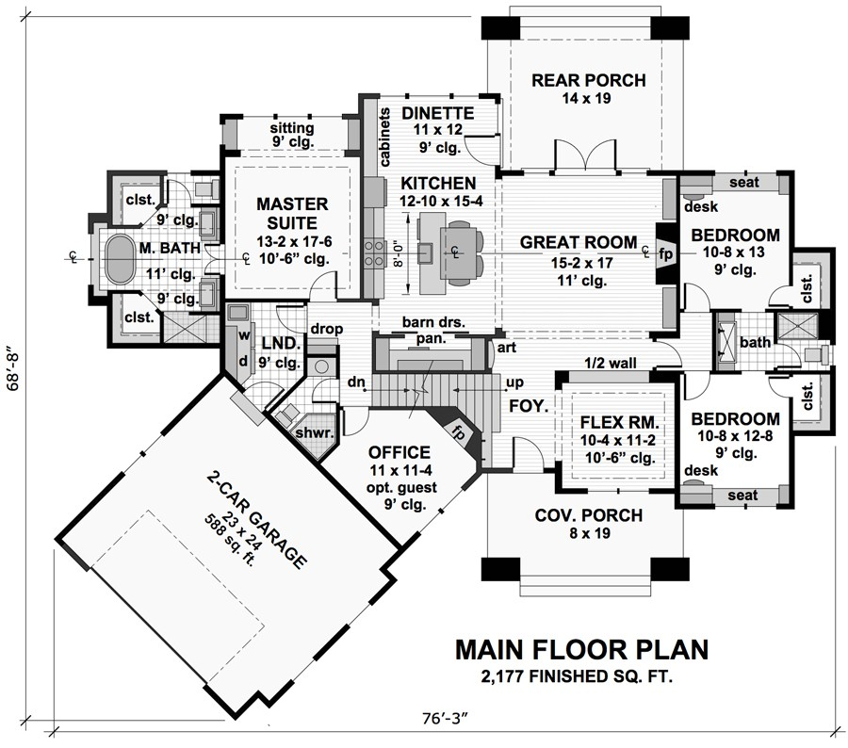
POOL

LA CASA DE LOS HERNANDEZ
DINING ROOM

Front porch

LIVING ROOM
HALL

BATHROOM
BALCONY
MASTER
BEDROOM
BATH
STAIRS

PATIO

