Grade 4 Spanish – Week April 27-30 lesson 1
Las emociones y los estados fisicos (feelings and emotions)
OBJECTIVE | ACTIVITIES | RESOURCES
Get familiar with the new vocabulary. | ACTIVITY 1:  - Read aloud the words from the new vocabulary  - Study the words  Vocabulary:  Estoy: I am Enfermo: Sick  Contento: content Feliz: happy  Nervioso: nervous Cansado: tired  Triste: sad Aburrido: bored  Confundido: confused Asustado: scared  Calmado: calm Avergonzado: embarrassed  Apenado: ashamed Enojado: angry  Orgulloso: proud Satisfecho: satisfied  Enfadado: upset Feliz: happy  Aterrado: terrified Preocupado: worried  Soñoliento: dozy  ACTIVTY 2:  Look at the pictures and the feelings and emotions in English and then use the word bank to write the correct Spanish meaning under each picture. If you can print, draw the face and then write the beside the feeling in Spanish.  Once you complete assignment upload on Seesaw on the Spanish folder.  Dios les bendiba | - Worksheet “ las emociones y los estados fisicos ” printed or be able to see on a device.  Computer or device.

Nombre:______________________________
Look at the pictures and the feelings and emotions in English and then use the word bank to write the correct Spanish meaning under each picture.
Sick
Angry
Ashamed
Content
_______________ _______________ _______________ __________________
Bored
Nervous
Sad
Tired
_______________ _______________ _______________ __________________
Scared
Proud
Calm
Confused
_______________ _______________ _______________ _________________

A. Orgulloso B. Enfermo C. Contento D. Nervioso E. Cansado
F. Triste G. Aburrido H. Confundido J. Asustado K. Calmado
L. Enojado M. Apenado

Grade 4 Spanish – Week April 27-30 lesson 2
Las emociones y los estados fisicos (feelings and emotions)
OBJECTIVE | ACTIVITIES | RESOURCES
Learn agreement between adjective and noun in Spanish. | ACTIVITY 1:  Read and carefully next page explaining the agreement between nouns and adjectives.  ACTIVTY 2:  Look at the pictures and then Write beside each picture the letter that correspond to the meaning in Spanish being aware of the rules between the adjective (feeling) and the noun.  Once you complete assignment upload on Seesaw on the Spanish folder.  Dios les bendiba | - Worksheet “ las emociones y los estados fisicos ” printed or be able to see on a device.  Computer or device.

Agreement between pronoun and adjective in Spanish.
In Spanish, adjectives (feelings) must agree with the pronoun they describe in gender and in number.
This means that if the person we are talking about is feminine, the adjective (feeling) must be feminine. If the word in Spanish ends in “O” we must change “O” to “A”. example:
contenta

Content

If the person we are talking about is masculine and the word (feeling) in Spanish ends in “O” the “O” remains.
contento

content

If we are talking about more than one girl, the adjective (feeling) must be feminine. If the word in Spanish ends in “O” we must change “O” to “AS”. example:
contentas

content

If we are talking about more than one boy, the adjective (feeling) must be masculine. If the word in Spanish ends in “O” we must to change“O” to “OS”. example:

contentos

Content
If we are talking about more than one boy and one girl or more, the adjective (feeling) must be masculine. If the word in Spanish ends in “O” we must to change” to “OS”. example:
contentos

content
Write beside each picture the letter that correspond to the meaning in Spanish.
Nombre:_________________

- 2.

- Enferma
- Enfermo
- Cansadas
- Asustado
- Asustadas
- Cansados
- Asustada
- Cansado
- Enojado
- Cansada

_______ _____
Tired tired

3. 4.
_______ _____

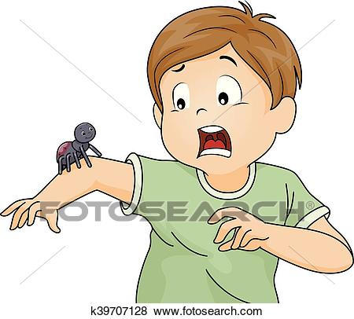
Scared tired
5. 6.

________ _____
Sick scared
7. 8.

__________ ______

Scared tired

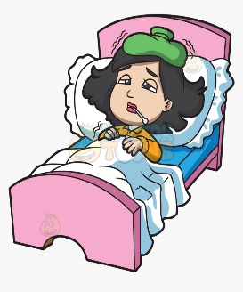
9. 10.

__________ ____

Angry sick

