Grade 4 Spanish – Week May 4-7 lesson 1
Las emociones y los estados fisicos (feelings and emotions)
Agreement between adjectives and nouns
OBJECTIVE | ACTIVITIES | RESOURCES
Learn agreement between adjective and noun in Spanish. | ACTIVITY 1:  Review; reed carefully next page explaining the agreement between nouns and adjectives.  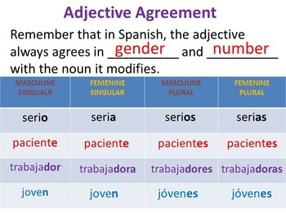  What does happen when there is boys and girls?  We use the masculine plural form .  ACTIVTY 2:  - Write the feeling and emotion under each picture that correspond to the meaning in Spanish being aware of the rules between the adjective (feeling) and the noun.  - In case you cant print it, write the feeling or emtion in English and then in Spanish.  Once you complete assignment upload on Seesaw in the Spanish folder.  Dios les bendiba | Access to internet  Computer or device.

Agreement between pronoun and adjective in Spanish.
In Spanish, adjectives (feelings) must agree with the pronoun they describe in gender and in number.
This means that if the person we are talking about is feminine, the adjective (feeling) must be feminine. If the word in Spanish ends in “O” we must change “O” to “A”. example:
contenta

Content

If the person we are talking about is masculine and the word (feeling) in Spanish ends in “O” the “O” remains.
contento

content

If we are talking about more than one girl, the adjective (feeling) must be feminine. If the word in Spanish ends in “O” we must change “O” to “AS”. example:
contentas

content

If we are talking about more than one boy, the adjective (feeling) must be masculine. If the word in Spanish ends in “O” we must to change“O” to “OS”. example:

contentos

Content
If we are talking about more than one boy and one girl or more, the adjective (feeling) must be masculine. If the word in Spanish ends in “O” we must to change” to “OS”. example:
contentos

content
Adjectives ending in: | Masculine singular | Feminine singular | Masculine plural | Feminine plural
-o/-a | pequeño | pequeña | pequeños | pequeñas
-e | triste | triste | tristes | tristdes
-or/-ora | trabajador | trabajadora | trabajadores | trabajadoras
a consonant | feliz | feliz | felices | felices

Adjectives and subjects agreements:

What does happen when there is boys and girls?
We use the masculine plural form.

Nombre:______________________________
Write the feeling and emotion under each picture that correspond to the meaning in Spanish being aware of the rules between the adjective (feeling) and the noun.
______________________ __________________________ ______________________

_________________________ ______________________________ ____________________

____________________________ _____________________________
Confundidos aburrido orgullosa
contentas tristes confundido
enojados enfermos

Grade 4 Spanish – Week May 4-7 lesson 2
Las emociones y los estados fisicos (feelings and emotions)
Verb “estar” (to be)
OBJECTIVE | ACTIVITIES | RESOURCES
Know the forms of the verb “estar” en first, second and third person | ACTIVITY 1:  Write in your book the follow:  In order to describe my feelings and emotions and how other feel, we need to know the forms of the verb to be” estar”.  Yo estoy - I am  Tú estás - you are  Él está - he is  Ella está - she is  We can also replace the personal pronouns for names and write the form of the verb that matches with the subject, example:  Ella está, María está – she is, María is.  Él está, Juan está - he is, Juan is.  ACTIVTY 3:  Let’s describe how I and others feel today  Yo estoy contento.  Ella esta emocionada.  ACTIVTY 4:  - Complete sentences by writing the correct formof the verb “estar”, next page.  - In case you cant print, write the complete senteces, take a picture and then send it to Sra. Powell email: FPowell@fbcs.edu.ky or upload on seesaw in the Spanish folder.  Dios les bendiba | Computer or device.  Access to internet.

Nombre:__________________________
Complete sentences by writing the correct formof the verb “estar”. Follow the example.
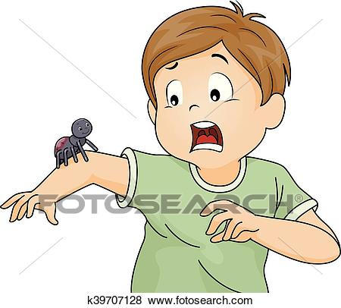

- Manuel está asustado.

- Ella ____________cansada.

- Lissette _________ asustada.

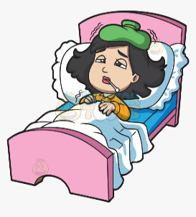

- Rosa___________ enferma.

- Marcos ___________ enfermo.

- Mateo___________ cansado.

