Grade 4 Spanish – Week May 18-22 lesson 2
Las emociones y los estados fisicos (feelings and emotions)
Verb “estar” (to be)
OBJECTIVE | ACTIVITIES | RESOURCES
Review the forms of the verb “estar” in plural form. | ACTIVITY 1:  Let’s review plural form of the verb to be” estar”.  Nosotros estamos - We are  Ellos están - they (boys) are  Éllas están - they (girls) are  Ustedes están - you all are  Let’s put everything together:  We are happy nosotros estamos alegres  They are sad ellos están tristes  ACTIVTY 3:  - Draw a line to match the picture with the feeling description in Spanish.  - In case you cant print, write the complete senteces and draw a face beside it. After take a picture and then send it to Sra. Powell email: FPowell@fbcs.edu.ky or upload on seesaw in the Spanish folder.  Dios les bendiga | Computer or device.  Access to internet.

Draw a line matching the feeling and emotion with the correct picture.
Nombre:__________________
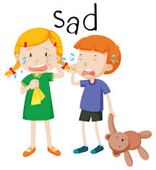 Ellos están confudidos.
Ellos están enfermos
Las niñas están contentas
Los niños están tristes
Los niños están enfermos

