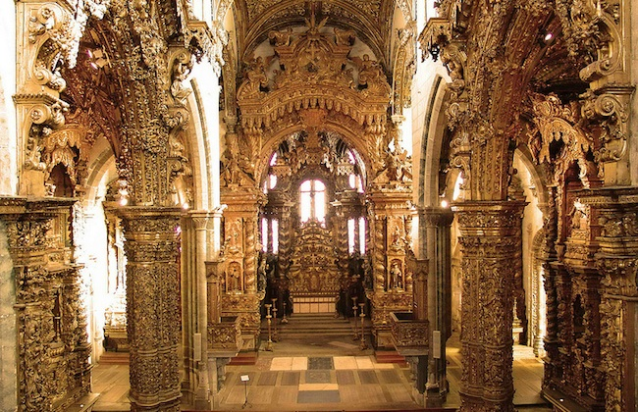 **Baroque or Not?**

**Listening Quiz**

Name Form

Listen carefully to the following extracts of music and decide whether you think the music is taken from the Baroque period or not. Jot down a brief reason why in the “notes” column to justify your decision.

|  |  |  |
| --- | --- | --- |
|  | **Baroque? YES/NO** | **Notes** |
| **Extract 1** |  |  |
| **Extract 2** |  |  |
| **Extract 3** |  |  |
| **Extract 4** |  |  |
| **Extract 5** |  |  |
| **Extract 6** |  |  |
| **Extract 7** |  |  |
| **Extract 8** |  |  |
| **Extract 9** |  |  |
| **Extract 10** |  |  |

** Baroque or Not?**

**Listening Quiz**

**TEACHER’S NOTES**

The **Baroque or Not? Audio** file to accompany this activity contains the following musical extracts.

**Extract 1 *– Extract from “Spring” from ‘The Four Seasons’ – Vivaldi (Baroque)***

**Extract 2 - *Extract from “Fanfare for All” – Babbitt (Not Baroque)***

**Extract 3 - *Extract from “Aquarium” from ‘Carnival of the Animals’ – Saint-Saens (Not Baroque)***

**Extract 4 - *Extract from “Allegro” from ‘Brandenburg Concerto No.3 in G Major BWV 1048 – J. S. Bach (Baroque)***

**Extract 5 - *Extract from “Air” from ‘Water Music’ – Handel (Baroque)***

**Extract 6 -*Variation from “America” – Charles Ives (Not Baroque)***

**Extract 7 - *Extract from “He Was Despised” from ‘Messiah’ – Handel (Baroque)***

**Extract 8 - *Extract from 1st Movement of Symphony No.5 – Mahler (Not Baroque)***

**Extract 9 - *Extract from “Un Bel Di” from ‘Madame Butterfly’ – Puccini (Not Baroque)***

**Extract 10 - *Extract from “But Thanks be to God” from ‘Messiah’ – Handel (Baroque)***

The following may prove useful in class discussion or clarification of the answers:

*Extract 1 was an example of Baroque music. It was a piece written by the Italian Baroque composer Vivaldi. The instruments used in this extract were all from the string family – a main feature of Baroque music along with the “tinkling” continuo of the Harpsichord together with the cello keeping the bass line of the music together. The light and joyful mood was the same throughout – and although there were contrasting dynamics, these were either loud or soft – remember “terraced dynamics”.*

*Extract 2 was most certainly not Baroque and was a Fanfare written in the 20th century for brass instruments and percussion. The mood of the music is far too heavy to be Baroque, the harmonies with their discords and clashes are just too experimental. Instruments like the snare drum just weren’t around during the Baroque period.*

*Extract 3 was certainly not Baroque either. The sound of the piano should be an instant clue for you to place the music in a much later period. The piano wasn’t invented until the Classical period which came after the Baroque period; however, this extract is from the Romantic period including a sliding, chromatic melody played by the piano towards the end of the extract.*

*It was “back to Bach” for Extract 4 and a very characteristic piece of Baroque music from another of Bach’s “Brandenburg Concertos”. The Harpsichord and cello play the continuo bass part while the string section performs the melody. The mood of the piece was light, in a distinctly major key and kept the same dynamics throughout – all very “Baroque”*

*Extract 5 was also distinctively Baroque - another extract from Handel’s “Water Music”. Characteristic of Baroque music were the highly decorated melody line with lots of trills, the “ever-present” Harpsichord, the oboe performing the melody first followed by the strings and the use of “terraced dynamics” – a loud – soft- loud- soft series of sections.*

*Extract 6 was written in the 20th century by the American composer Charles Ives. You may have recognised the theme as our national anthem. However, the orchestra that played this extract was too “full-sounding” to be Baroque – the snare drum, tambourine and castanets in the percussion section and the way in which the music “fades” out at the end are very typically un-Baroque!*

*Extract 7 was another piece from Handel’s “Messiah” and contained lots of features that made it distinctly Baroque. The melody was highly decorated with musical ornaments. The strings introduction contained lots of “imitation” – musical question and answers or echoing - and a melody line richly decorated with trills. There was even imitation between the voice and the strings towards the end of the extract. No Harpsichord here, but we do have the organ, taking on the role of the continuo with the cello, as this piece would have originally been performed in a church. l*

*Extract 8 was written much later than the Baroque period by the Romantic composer Mahler. The music is again too dramatic to be Baroque, the orchestral sound is too large and the fading of dynamics would not be found in the Baroque period.*

*Extract 9 is again written much later than the Baroque period and is taken from an opera. This music is again too dramatic, too expressive with too large an orchestral sound to be Baroque. The contrasting changes in dynamics and texture would be something that would become popular in music far later than the Baroque period.*

*It’s back to the Baroque and back to Handel for our final extract which had the characteristic Baroque-sounding instruments – mainly strings with oboe and organ continuo. There was lots of imitation between the vocal parts. The music had a very clear polyphonic texture with parts weaving and interweaving in and around each other. The piece very much “sounded the same” with little contrast giving it a true Baroque feel.*