First Baptist Christian School Learning Plan

Date: Wednesday, April 1st
Subject | Lesson | Resources
Literacy  Objectives:  Show comprehension for the fictional text  Show understanding of plot and setting  Show character development | Listen to the Youtube video for Chapter 22 - the last Chapter  Chapter 22: https://youtu.be/A7XZ-OjFMeI  Write a summary of the last Chapter  Complete the booklet - My Side of The Mountain - check for any unfinished pages | My Side of the Mountain booklet  Paper or Composition book
Math  Objective: Learn the methods for finding volume and apply | We are learning a new concept – Volume!  Not like the sound but a form of measurement. (:  Basic concept:  Finding the volume is finding the space inside of a shape.  For shapes, there are specific ways to multiply:  - Cube: side x side x side = answer to the 3rd power (the little 3)  - Rectangular prism: length x width x height = also having to put a little 3  Example:  Cube: side x side x side = ?  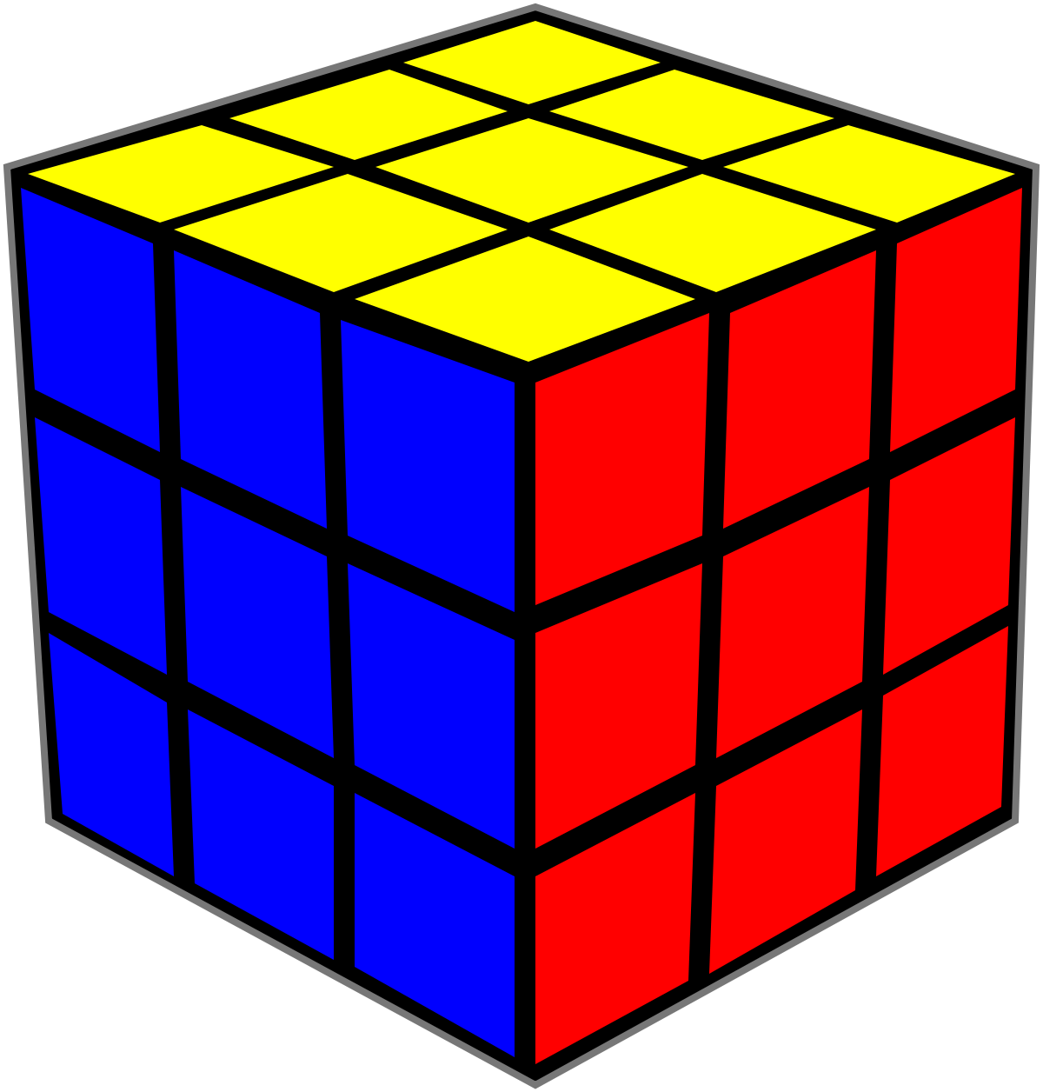 3 x 3 x 3 = 27  Rectangular Prism:  length x width x height = ? 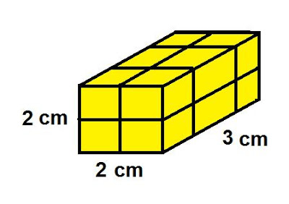 2 x 3 x 2 = 12  Activity:  - Watch video: https://youtu.be/LZxXUb9iAZc  - Use Seesaw to complete activity on finding volume. | Youtube video  Seesaw
Science | Sound Project due tomorrow!
Social Studies | Turn in the Country project –  download to assignments in Microsoft Teams.
Bible  God looks at our heart - the choices we make reflect if we have a good heart attitude or a bad heart attitude.  David had a good heart attitude and his words and actions reflected that.  Make sure your words and actions reflect a good heart attitude.  How can you help someone at home today? | Read Mark 12 : 29 - 31  Believers need to love God and to love others.  Read 1 Samuel 18 : 5, 14, 30 and 1 Samuel 24 : 6  David usually acted wisely everywhere he went.  There was one exception -  Read 1 Kings 15 : 5  Complete workbook Pg 80  Write down good choices that David made, then complete choices you can make to reflect a good heart attitude. | Bibles  Bible workbooks

