Grade 5 Spanish – Week May 4-7 lesson 1
Los quehaceres en casa (house chores)
OBJECTIVE | ACTIVITIES | RESOURCES
Improve reading in Spanish and show understanding to the verbs conjugations. | ACTIVITY 1:  Read the follow and pay attention to it:  How is a verb divided? Ar verbs endings  yo o  Tú as  Él, ella usted a  Nosotros amos  Vosotros áis  Ellos, ellas, ustdes an  Habl/ar  Stem  ending  Let’s use verb trapear  Yo trapeo. we leave the steam which is TRAPE and then add the correct ending O.  ACTIVITY 2:  Read the schedule of Rachel and draw and check mark under the picture on the day she does that specific chore.  If document can’t be printed write the day and the activity.  Once is completed, send by email to Sra. Powell; FPowell@fbcs.edu.ky or upload on Seesaw in the Spanish folder  Dios les bendiba | - Computer or device.  - Access to internet

Nombre:___________________ ___
Read Rachel chores’ schedule and mark with a check mark under each picture the day she does the chores.

Hola me llamo Rachel, yo soy de Cuba, soy cubana. Tengo 11 años. Yo ayudo en los quehaceres en mi casa todos los días.
El lunes yo cocino en casa. El martes yo trapeo. El miércoles yo riego las plantas, el jueves lavo los platos. El viernes saco la basura. El sábado yo paso la aspiradora y el domigo yo lavo el carro y lavo los platos.
 |  | 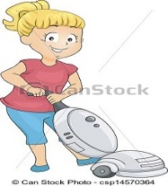 |  |  | 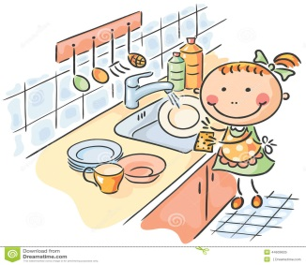
Lunes
Martes
Miércoles
Jueves
Viernes
Sábado
Domingo

Grade 5 Spanish – Week May 4-7 lesson 2
Los quehaceres en casa (house chores)
OBJECTIVE | ACTIVITIES | RESOURCES
Improve reading in Spanish and show understanding to the verbs conjugations. | ACTIVITY 1:  Read the follow and pay attention to it:  How is a verb divided? Ar verbs endings  yo o  Tú as  Él, ella usted a  Nosotros amos  Vosotros áis  Ellos, ellas, ustdes an  Habl/ar  Stem  ending  Let’s use verb trapear  Yo trapeo. we leave the steam which is TRAPE and then add the correct ending O.  ACTIVITY 2:  Read the schedule of Samuel and draw and check mark under the picture on the day she does that specific chore.  If document can’t be printed write the day and the activity.  Once is completed, send by email to Sra. Powell; FPowell@fbcs.edu.ky or upload on Seesaw in the Spanish folder  Dios les bendiba | - Computer or device.  - Access to internet

Nombre:______________________
Read Samuel chores’ schedule and mark with a check mark under each picture the day she does the chores.

Hola, me llamo Samuel, yo tengo 12 años, yo soy de Nicaragua. En mi casa todos ayudamos en los quehaceres de la casa, yo ayudo todos los dias. Los lunes yo riego las plantas, el martes yo preparo el almuerzo, el miércoles yo lavo el carro de mamá, los jueves yo lavo los platos, el viernes yo paso la aspiradora y trapeo, y el domingo yo saco la basura.
 |  | 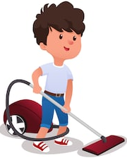 |  |  |  |  | 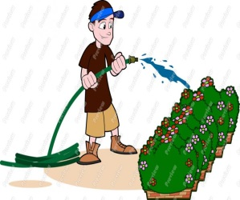
Lunes
Martes
Miércoles
Jueves
Viernes
Sábado
Domingo

