What is Sound?
This text is excerpted from an original work of the Core Knowledge Foundation.
An alarm clock rings, a dog barks, a voice calls, “Time to get up!” Every day is full of familiar sounds, but what exactly is sound?
Sound is caused by a back and forth movement called vibration. Try this. Close your lips and hum. While you are humming, feel your throat under your chin. Do you feel something buzzing or vibrating? What you feel is caused by something moving back and forth very fast. When you hum, the vocal cords in your throat vibrate back and forth. This makes the air around them vibrate, which then creates the sound you hear.
When you hum, your vocal cords vibrate to make sounds.
Sound, like light, is a form of energy. Also like light, sound moves in waves. Sound waves move out from a vibrating object, making the air move back and forth in a way that we can’t see.
Two things must happen to create a sound. First, something needs to vibrate and create sound waves. Then, something like air or another medium needs to carry the sound waves. You hear sounds more clearly if you are close to whatever is vibrating and making the sound waves. The farther away that the sound waves spread out, the weaker they get. That is why you can hear a friend standing right next to you better than if they are calling to you from across the street.
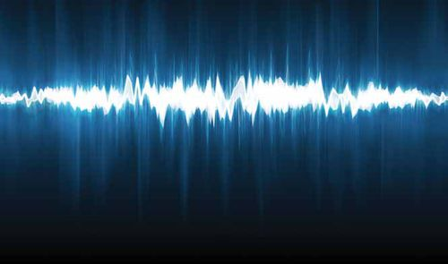
This is what a sound wave might look like if we could see it.

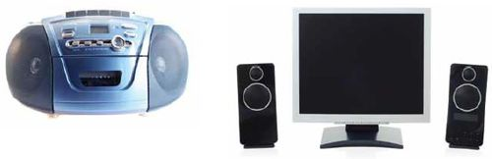
The next time you turn on your radio or TV, lightly put your fingers on the speakers. Do you feel the sound vibrations?

Sound travels not only through air, which is a gas, but through other mediums. In fact, sound can travel through solids, liquids, and gases.
Think about sound traveling through solids, like a window or even a closed door. If you are close enough, you can still hear sounds on the other side of a window or door.
How about liquids? Have you ever been underwater in a swimming pool when you have heard someone’s voice or another sound? It probably sounded different than it would if you were not under water, but you were still able to hear it. This is an example of sound traveling through a liquid—the water in the pool.
One place that sound cannot travel is in outer space. Sound cannot travel through the emptiness, or vacuum, of space. There is no sound in outer space because there is no medium to carry it.

Sound travels through solids, liquids, and gases (air).

