Los Quehaceres en casa vocabulary
Quehaceres: chores La aspiradora: vacuum
Preparar: to prepare Tomar: to take
cocinar: to cook Barrer:to sweep
Limpiar: to clean Arreglar: to tidy up Lavar: to wash Pasar la aspiradora: vacuuming
Sacar la basura: take out the trash. Quitar: to remove
Regar las plantas: to water plants Los platos: dishes
La escoba: broom Trapear: to mop
Recoger: to pick up Planchar: to iron
Caminar al perro: to walk the dog El trapeador: the mop
La ropa: cloth

Bingo los quehaceres  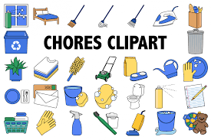  Los quehaceres | La aspiradora | Preparer | Caminar al perro
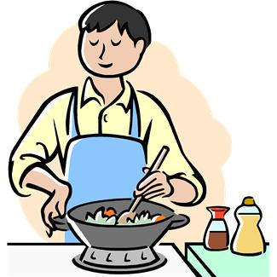  cocinar | 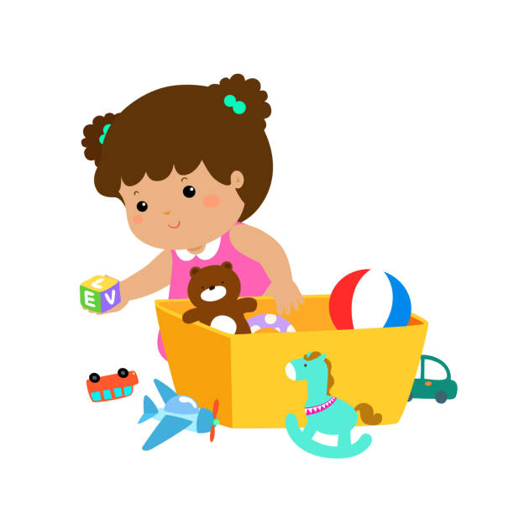  Arreglar | 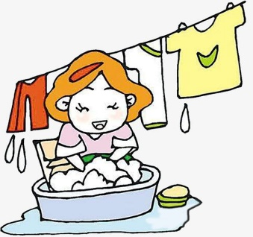  Lavar | Tomar
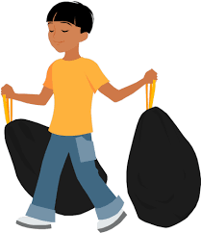  Sacar la basura | 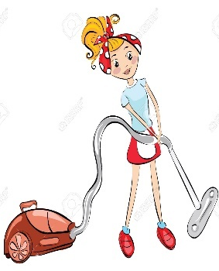  Pasar la aspiradora | 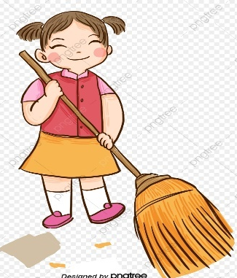  Barrer | 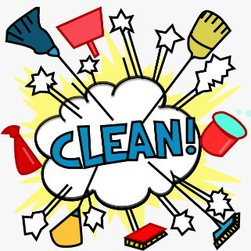  Limpiar
Quitar | 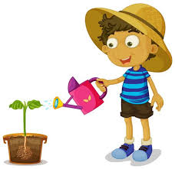  Regar las plantas | 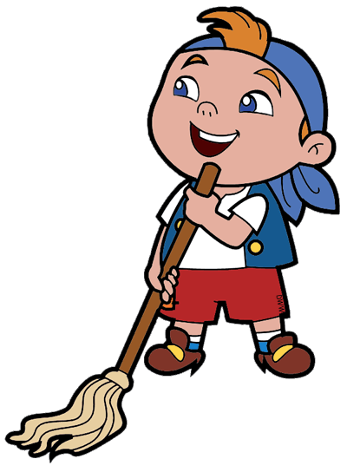  Mopear | 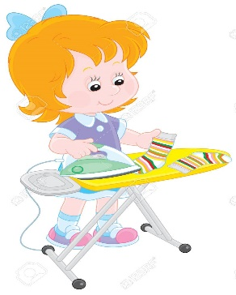  Planchar

Bingo los quehaceres

 | 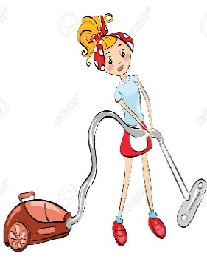 | 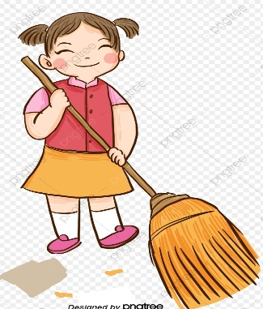

Grade 5 Spanish – Week April 20-23 lesson 1
Los quehaceres
Lesson Objective | To identify chores in Spanish
Supplies | Worksheet “la ropa” printed or be able to see on a device
 | Computer/Phone with Internet
Vocabulary | Quehaceres: chores La aspiradora: vacuum  Preparar: to prepare Tomar: to take  cocinar: to cook Barrer:to sweep  Limpiar: to clean Arreglar: to tidy up Lavar: to wash Pasar la aspiradora: vacuuming  Sacar la basura: take out the trash. Quitar: to remove Regar las plantas: to water plants  La escoba: broom Trapear: to mop  Recoger: to pick up Planchar: to iron  Caminar al perro: to walk the dog  El trapeador: the mop los platos: dishes  La ropa: cloths
Step 1 | Look at the pcitures and read the the meaning in Spanish.
Step 2 | Play bingo “los quehaceres”. After you master the ropic, play bingo, make some one call the words and then mark the correct picture.

